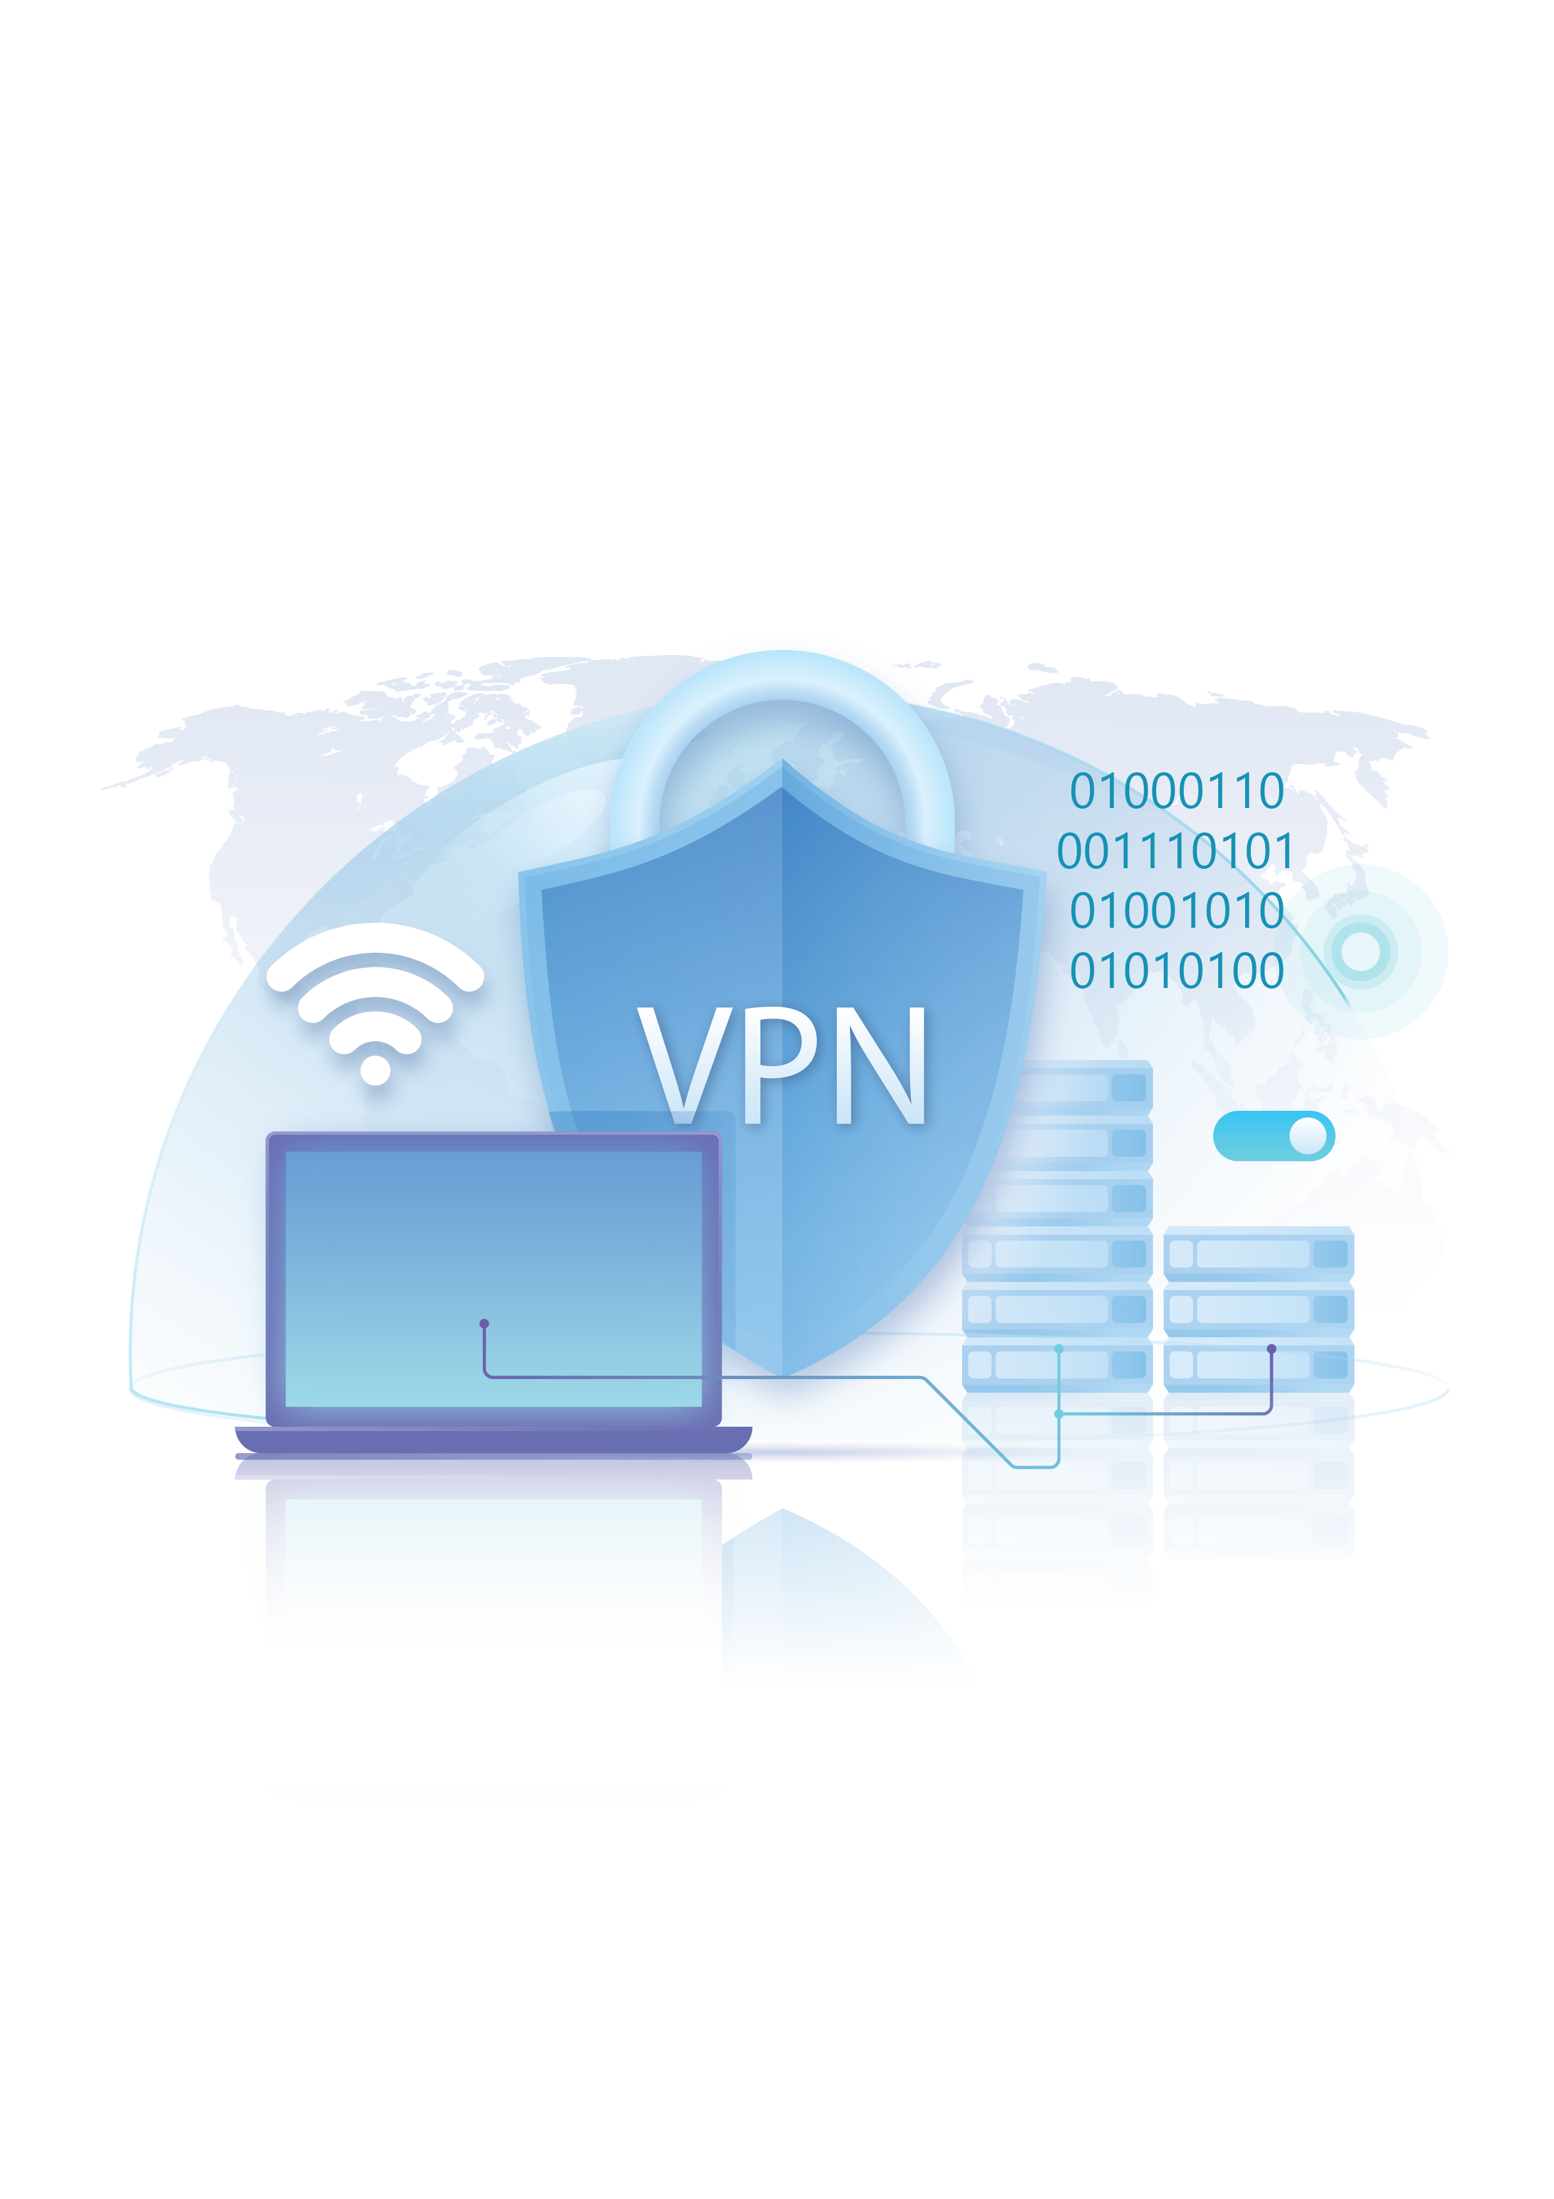

***Supervised by:***

*Eng. Ahmed Mahmoud*

***Team Members:***

1. *Abdelrhman Ahmed Abdelmonem*
2. *Mohamed Sameh Saeed*
3. *Hana Emad Isaac*
4. *Roaa Mohamed Said*
5. *Abdullah Tamer Ali*
6. *Raghad Ashraf Ibrahim*

Digital Egypt Pioneers Initiative (DEPI)

**Implementing VPN Solutions Project**

Fortinet Cybersecurity Engineer Track

Table of Contents

**Project 3: Implementing VPN Solutions with FortiGate** 2

**Introduction** 2

**Week 1: VPN Concepts and SSL VPN Configuration** 3

**a)** **VPN Overview** 3

**b)** **Types of VPNs and Their Use Cases** 3

**c)** **SSL VPN** 4

**d)** **SSL VPN Configuration on FortiGate** 7

**Week 2: IPsec VPN Configuration** 10

**a) Overview** 10

**b) How IPsec VPN Works** 10

**c) Key Components** 10

**d) IPsec Configuration Steps on FortiGate** 11

**e) Testing and Verification** 16

**f) Advantages of IPsec VPN** 19

**Week 3: FortiGate VPN with SD-WAN Integration** 20

**a) Overview** 20

**b) Benefits of SD-WAN Integration** 20

**c) SD-WAN Configuration on FortiGate** 20

**d)** **Testing and Performance Evaluation** 26

**Conclusion** 29

**References** 29

**Project 3: Implementing VPN Solutions with FortiGate**

**Introduction**

In today’s digital era, secure communication over public networks is a critical requirement for organizations of all sizes. As businesses expand and remote work becomes more common, ensuring data privacy, integrity, and secure access to internal resources has become a major focus in network security.

This project, “Implementing VPN Solutions with FortiGate,” aims to explore, design, and implement various VPN technologies using Fortinet’s FortiGate firewall platform. The primary goal is to provide secure connectivity between users, branches, and cloud networks by leveraging VPN configurations such as SSL VPN, IPsec VPN, and SD-WAN integration.

Throughout the project, different VPN types will be studied, configured, and tested to evaluate their performance and security capabilities. By the end of the project, a complete and well-documented VPN solution will be presented, demonstrating how FortiGate can effectively secure communication across distributed environments while optimizing network performance through SD-WAN features.

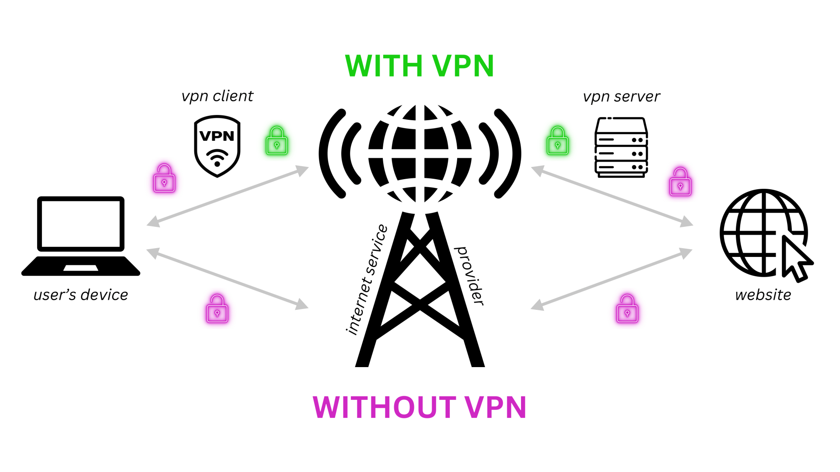

**Week 1: VPN Concepts and SSL VPN Configuration**

1. **VPN Overview**

A **Virtual Private Network (VPN)** is a secure communication technology that enables users or entire networks to connect over the public internet as if they were part of a single private network. It achieves this by creating an encrypted “tunnel” that protects data as it travels between devices or sites, preventing unauthorized access or interception. VPNs play a vital role in maintaining **data confidentiality, integrity, and authentication**, ensuring that sensitive information remains secure even when transmitted across untrusted networks.

In modern organizations, VPNs are widely used to allow remote employees to access internal resources safely, to connect multiple branch offices securely, and to enable encrypted communication between data centers or cloud services. By using strong encryption algorithms and authentication methods, VPNs not only enhance network security but also support flexibility and productivity, allowing users to work securely from virtually anywhere.

1. **Types of VPNs and Their Use Cases**

|  |  |  |
| --- | --- | --- |
| Type | Description | Use Case |
| Remote Access VPN (Client-to-Site VPN) | Connects individual users (like employees working remotely) securely to a company’s internal network using VPN client software. | Employees accessing company resources securely from home or while traveling. |
| Site-to-Site VPN | Connects two or more networks (e.g., branch offices) securely over the internet. Usually implemented between routers or firewalls. | Securely connecting branch offices or remote sites to headquarters. |
| SSL VPN (Secure Sockets Layer VPN) | Uses HTTPS (port 443) to provide secure remote access via a web browser or client. It encrypts traffic using SSL/TLS protocols. | Users who need access without installing special VPN clients (works through browsers). |
| IPsec VPN (Internet Protocol Security VPN) | Uses the IPsec protocol suite to encrypt and authenticate IP packets between sites or devices. It operates at the network layer. | Permanent, secure tunnels between offices or datacenters. |
| MPLS VPN (Multiprotocol Label Switching VPN) | Uses service provider networks to create private paths for enterprise traffic, ensuring reliability and QoS. | Large enterprises require scalable and reliable WAN connections. |
| L2TP/IPsec VPN | Combines Layer 2 Tunneling Protocol with IPsec encryption. Often used for secure remote access. | Legacy systems or networks requiring layer-2 tunneling. |
| Cloud VPN | Extends on-premises networks securely to cloud services (AWS, Azure, etc.). | Hybrid cloud environments. |

1. **SSL VPN**

**Overview**

An SSL VPN allows secure remote access to a private network using a standard web browser or a lightweight VPN client. It operates over the SSL/TLS protocol, the same technology used to secure websites (HTTPS). Because it uses port 443, SSL VPN traffic can pass easily through most firewalls and network devices without requiring special configurations.

SSL VPNs are widely used by organizations to enable remote employees, partners, or clients to securely access internal applications, files, or systems over the internet.

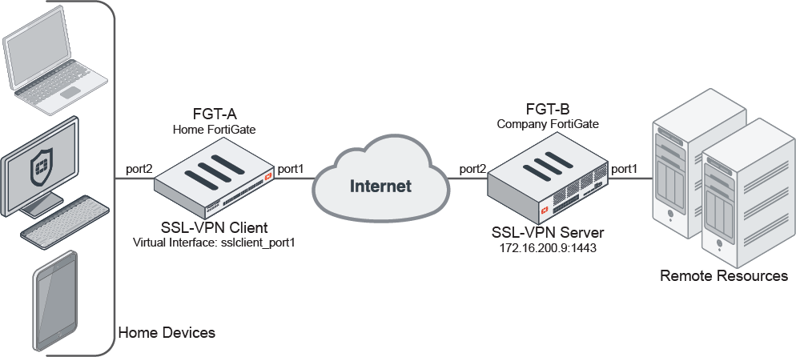

**Why SSL VPN?**

* Uses **HTTPS (port 443)** — easily passes through firewalls.
* Provides **user-based authentication**.
* Doesn’t require a special client (can work in a browser).
* Offers **tunnel mode** (for full network access) and **web mode** (for portal-based access).

**How It Works**

* The user connects to the SSL VPN gateway (e.g., FortiGate) through a **web browser** or **FortiClient VPN application**.
* The connection is established using **SSL/TLS encryption**, ensuring data transmitted between the user and the VPN gateway is secure.
* Once authenticated, the user is granted access to internal resources depending on the assigned privileges.

**Modes of SSL VPN**

There are typically **two modes** of SSL VPN operation:

1. **Web Mode**

* Access through a web portal.
* Users log in via a browser (e.g., https://<public-ip>:443) and can access specific applications like email, file servers, or web-based tools.
* Suitable for simple, controlled access without installing a VPN client.

1. **Tunnel Mode**

* Requires a VPN client (e.g., FortiClient).
* Creates a full network tunnel between the user’s device and the internal network.
* Allows complete access to internal network resources as if the user were on-site.
* Ideal for IT staff or employees who need broader network access.

**Advantages of SSL VPN**

* **Ease of Use:** Works through browsers and common ports (443).
* **Strong Encryption:** Uses SSL/TLS protocols for secure communication.
* **Flexible Access:** Supports both web-based and full-tunnel connections.
* **Firewall-Friendly:** Easily passes through NAT and firewalls.
* **User-Based Authentication:** Integrates with LDAP, RADIUS, or local users.

**Common Use Cases**

* Secure remote access for employees working from home.
* Business partners accessing limited company resources.
* Mobile users connecting from public networks (e.g., hotels, airports).

1. **SSL VPN Configuration on FortiGate**

**Objective:**

Configure an SSL VPN to allow remote users to access internal network resources securely.

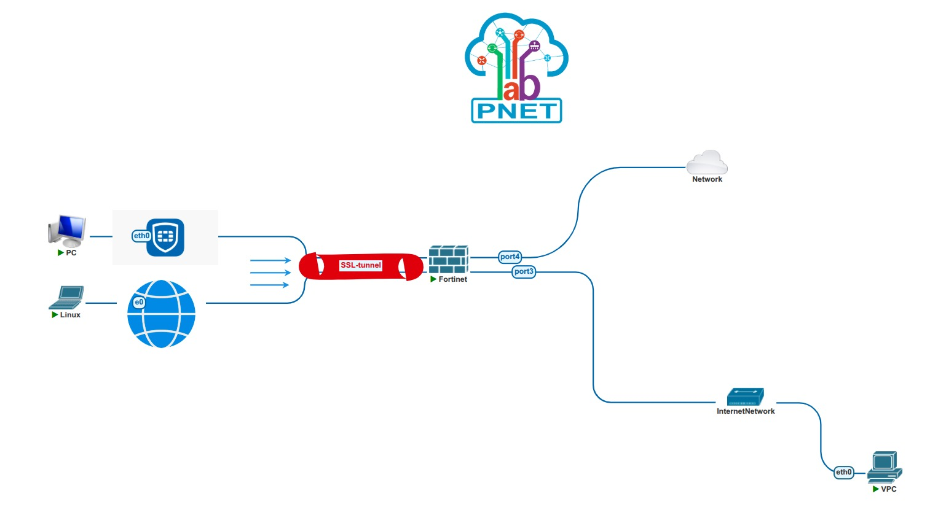

**SSL VPN Topology**

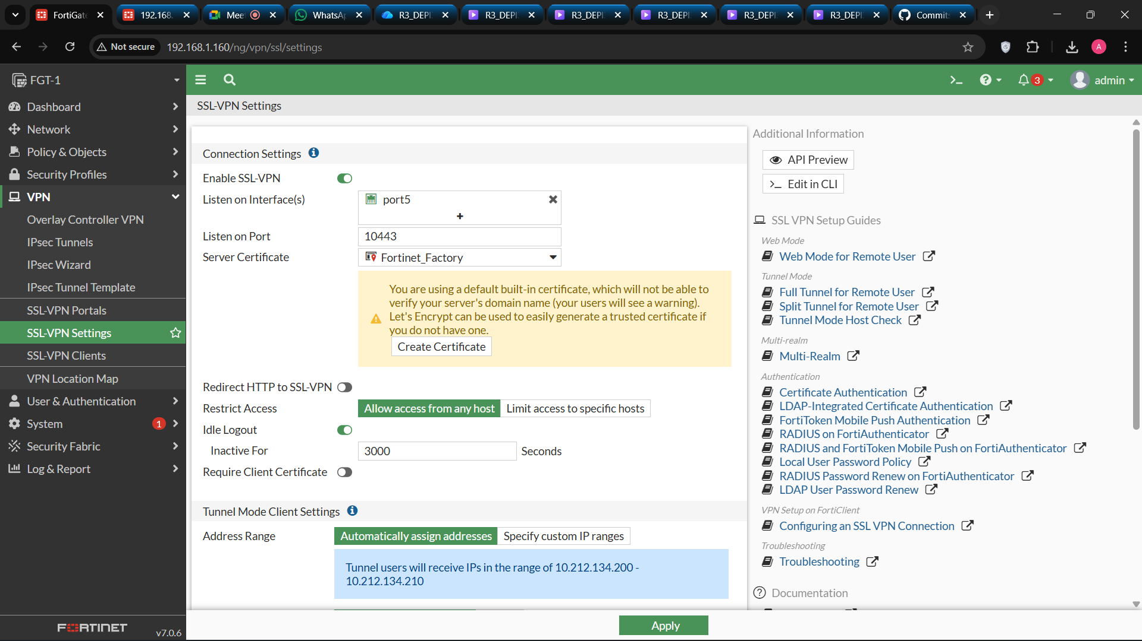

**SSL-VPN Setting Configuration:**



**SSL-VPN Portal Configuration:**

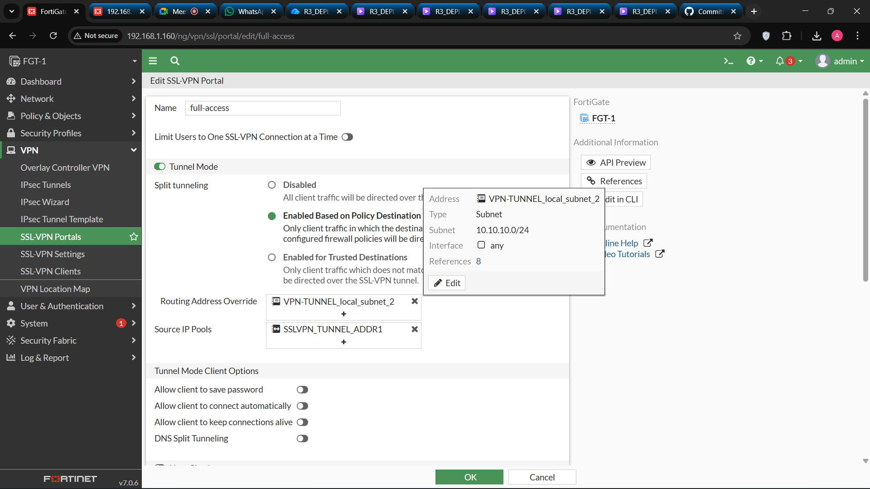

**SSL-VPN-Access Policy Configuration:**

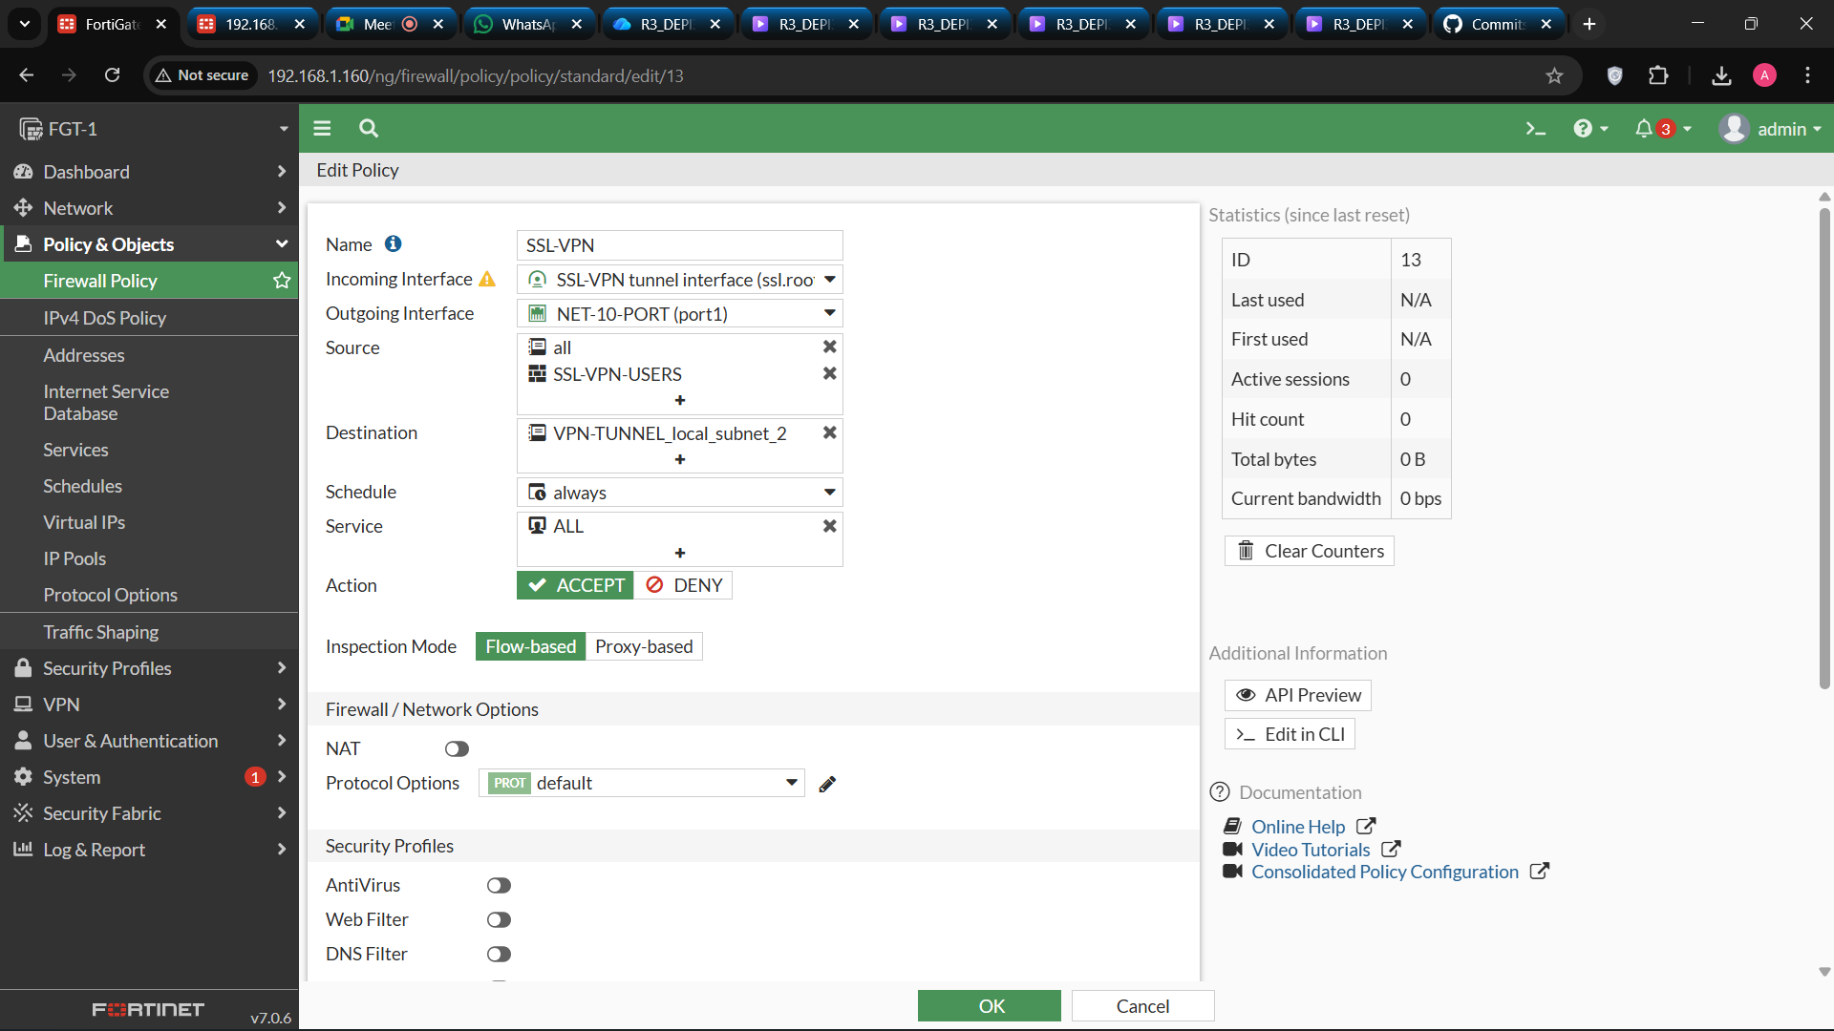

**Week 2: IPsec VPN Configuration**

**a) Overview**

The **IPsec (Internet Protocol Security) VPN** is a widely used protocol suite that secures network traffic by encrypting and authenticating IP packets at the **network layer (Layer 3)**. It provides site-to-site and remote access solutions that ensure data confidentiality, integrity, and authenticity between two or more networks.

IPsec VPNs are particularly suitable for organizations that need **permanent, secure connections between branches, headquarters, or data centers**.  
Unlike SSL VPNs, which are typically used for individual remote access, IPsec VPNs operate transparently for entire subnets and devices.

**b) How IPsec VPN Works**

An IPsec VPN establishes a **secure tunnel** between two FortiGate devices through a two-phase process:

**Phase 1 (IKE Negotiation):**

* 1. Establishes a secure communication channel.
  2. Authenticates the two VPN peers.
  3. Negotiates encryption and hashing algorithms (e.g., AES, SHA).

**Phase 2 (Data Encryption):**

* 1. Defines traffic selectors (networks that will communicate).
  2. Encrypts user data packets through the established tunnel.

**c) Key Components**

* **IKE (Internet Key Exchange):** Used for secure key exchange.
* **ESP (Encapsulating Security Payload):** Provides encryption and authentication.
* **AH (Authentication Header):** Ensures integrity and authenticity (used optionally).
* **Transform Sets:** Define algorithms for encryption and hashing.

**d) IPsec Configuration Steps on FortiGate**

* 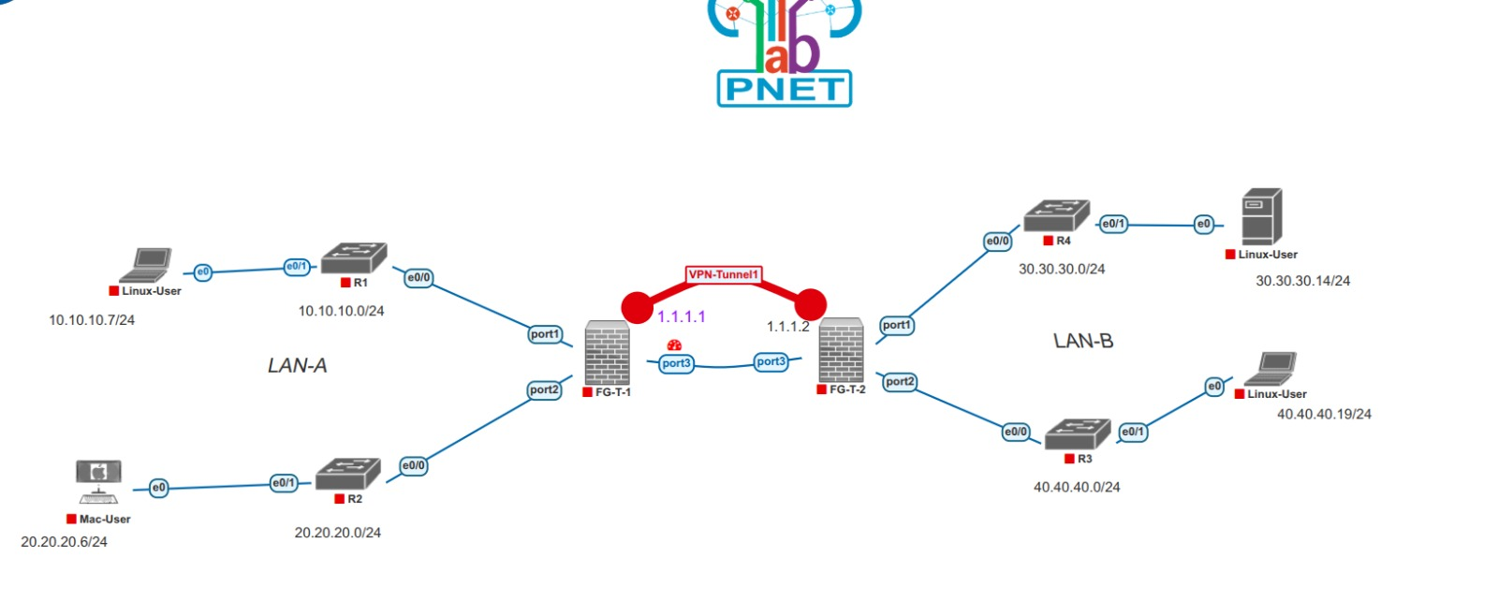**Objective:**  
  Establish a secure IPsec tunnel between two FortiGate firewalls (e.g., between Head Office and Branch).

**IPsec VPN Tunnel Topology**

* 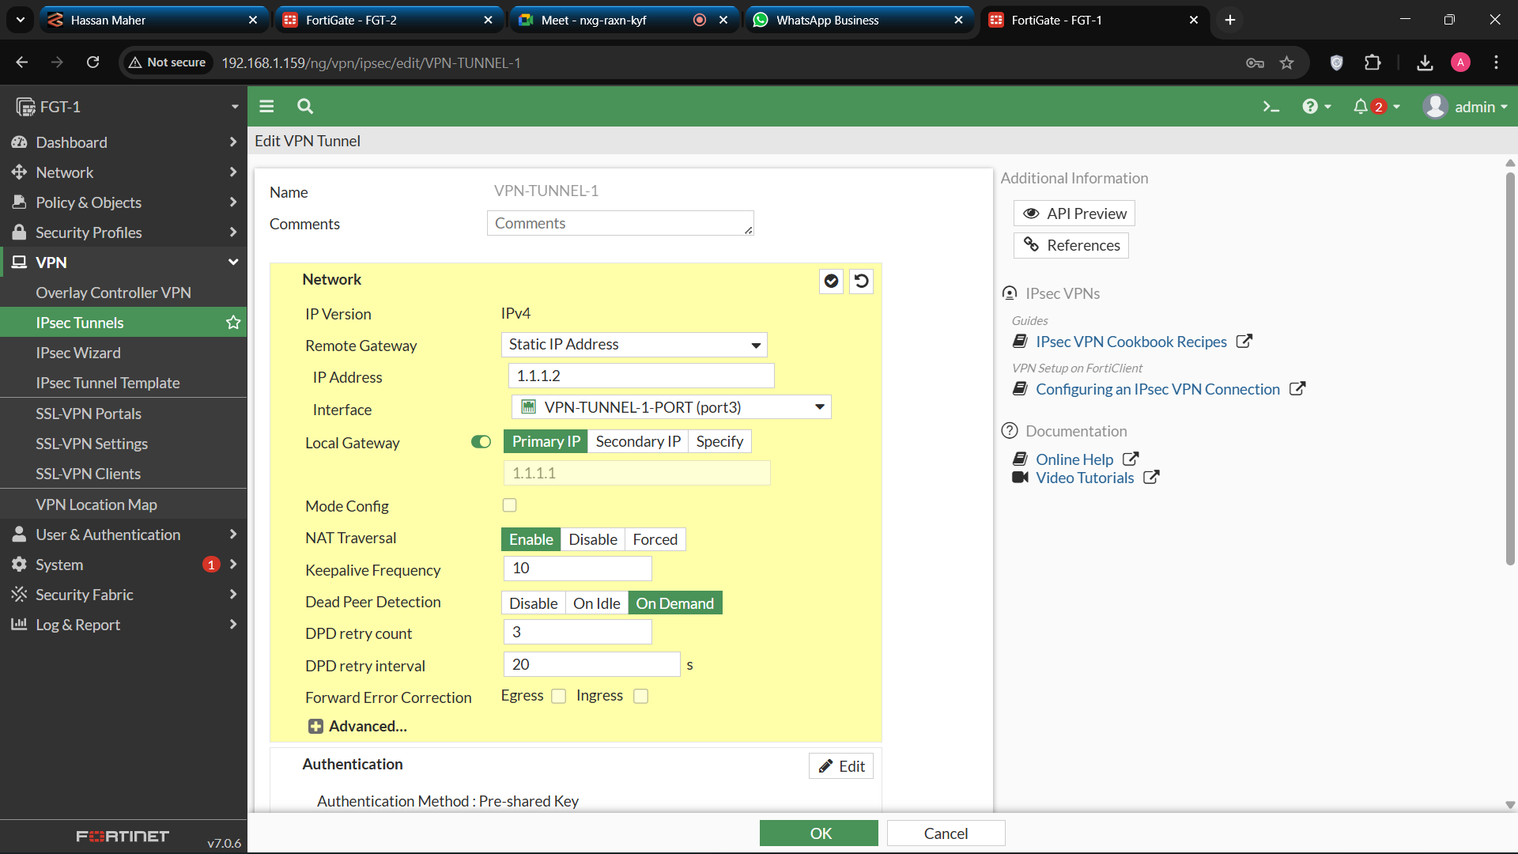**Configuration Steps: Step1: Configure VPN Tunnels**

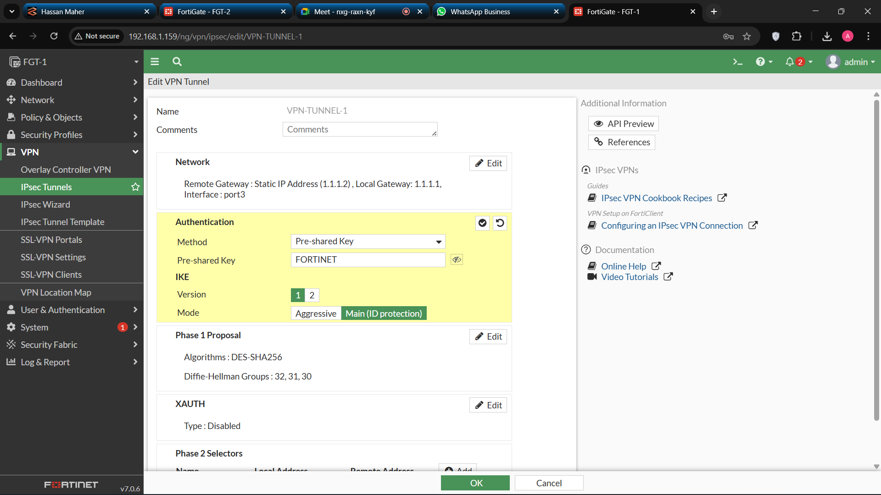

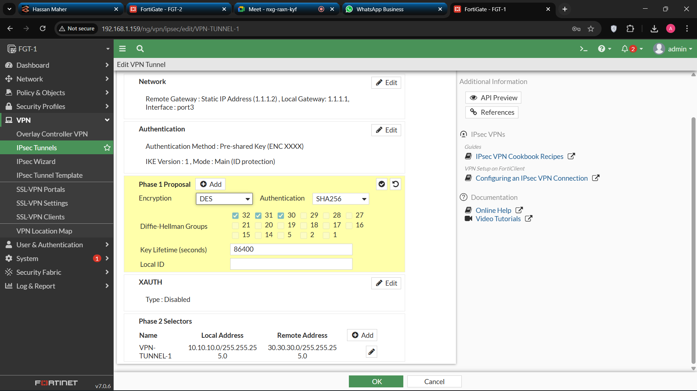

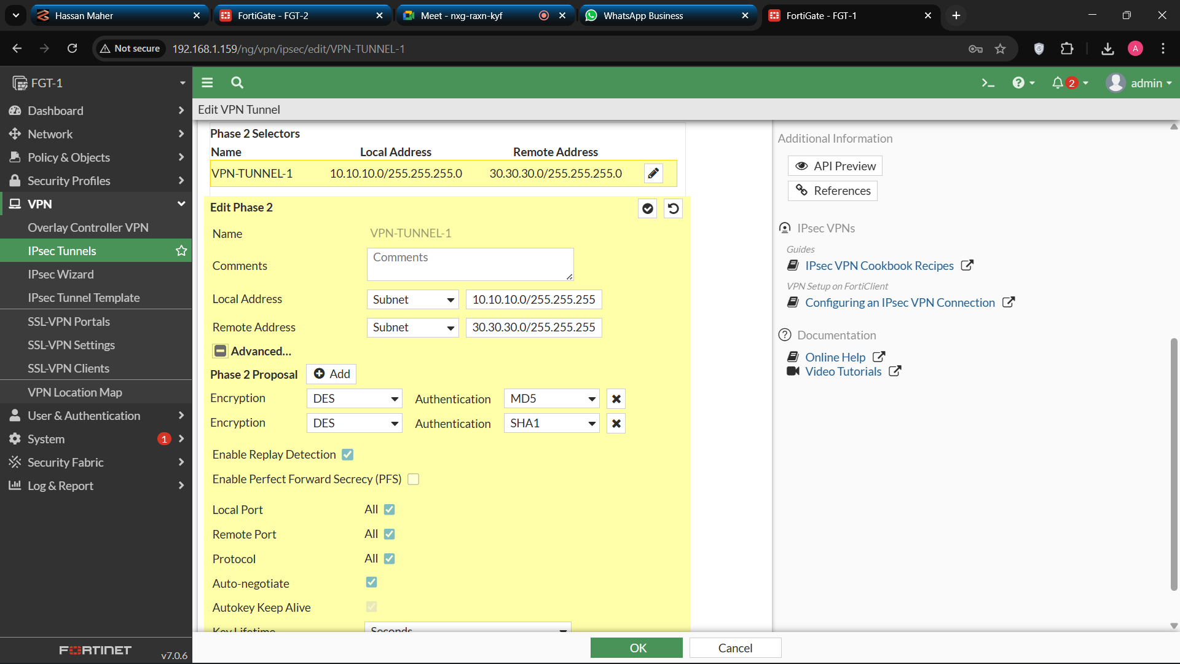

**Step 2: Set Static Routes**

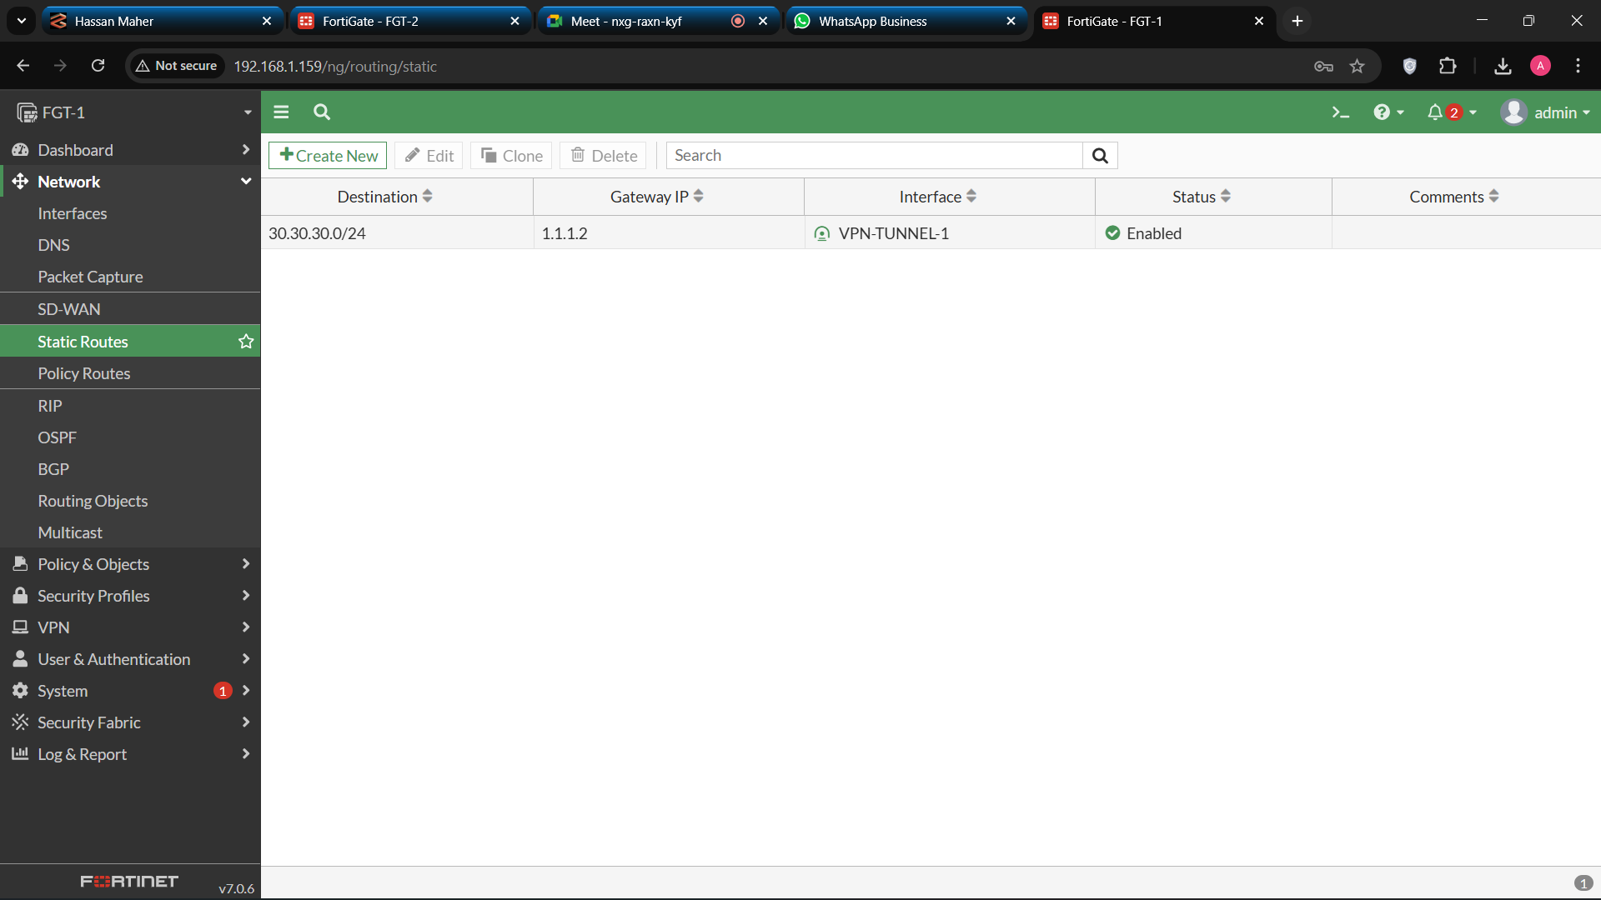

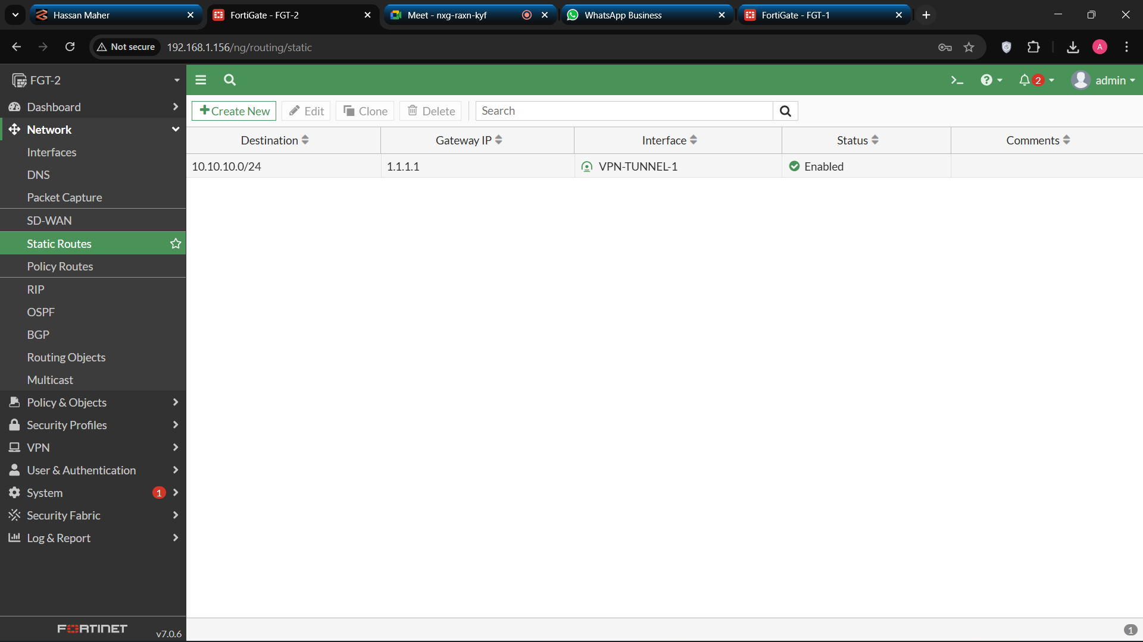

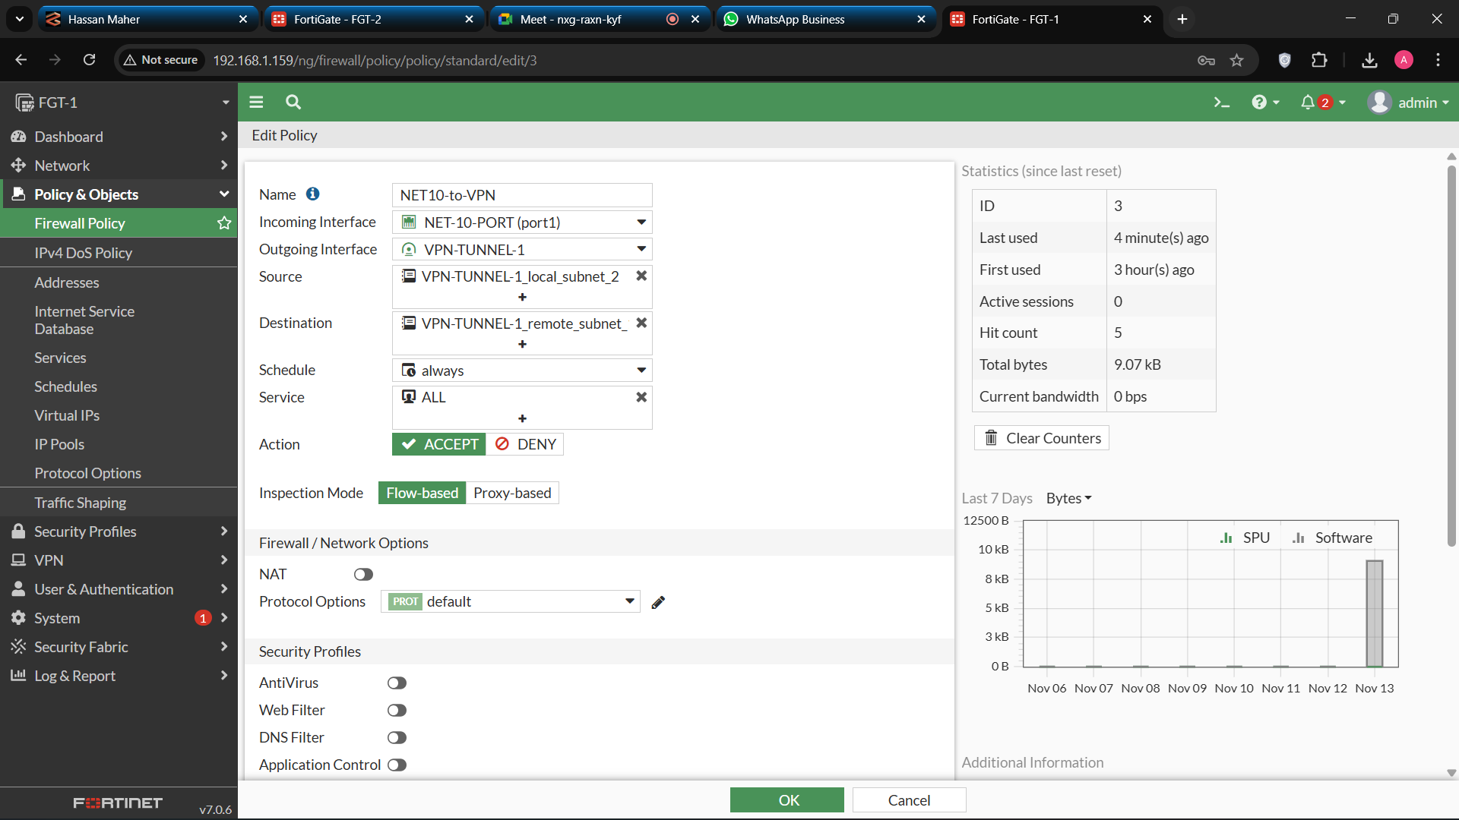**Step 3: Configure Policies**

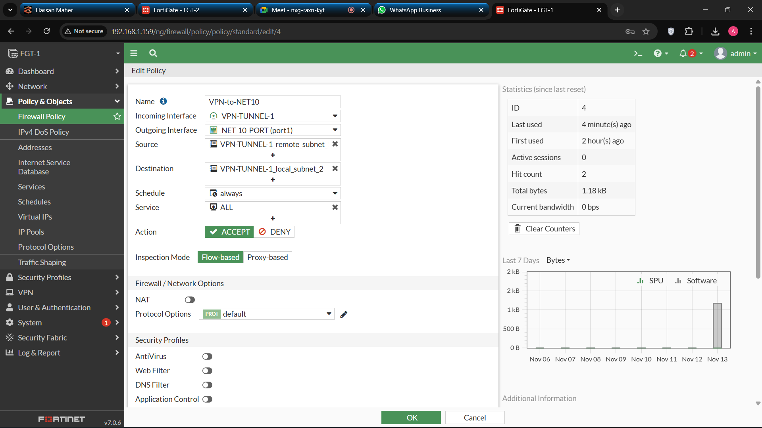

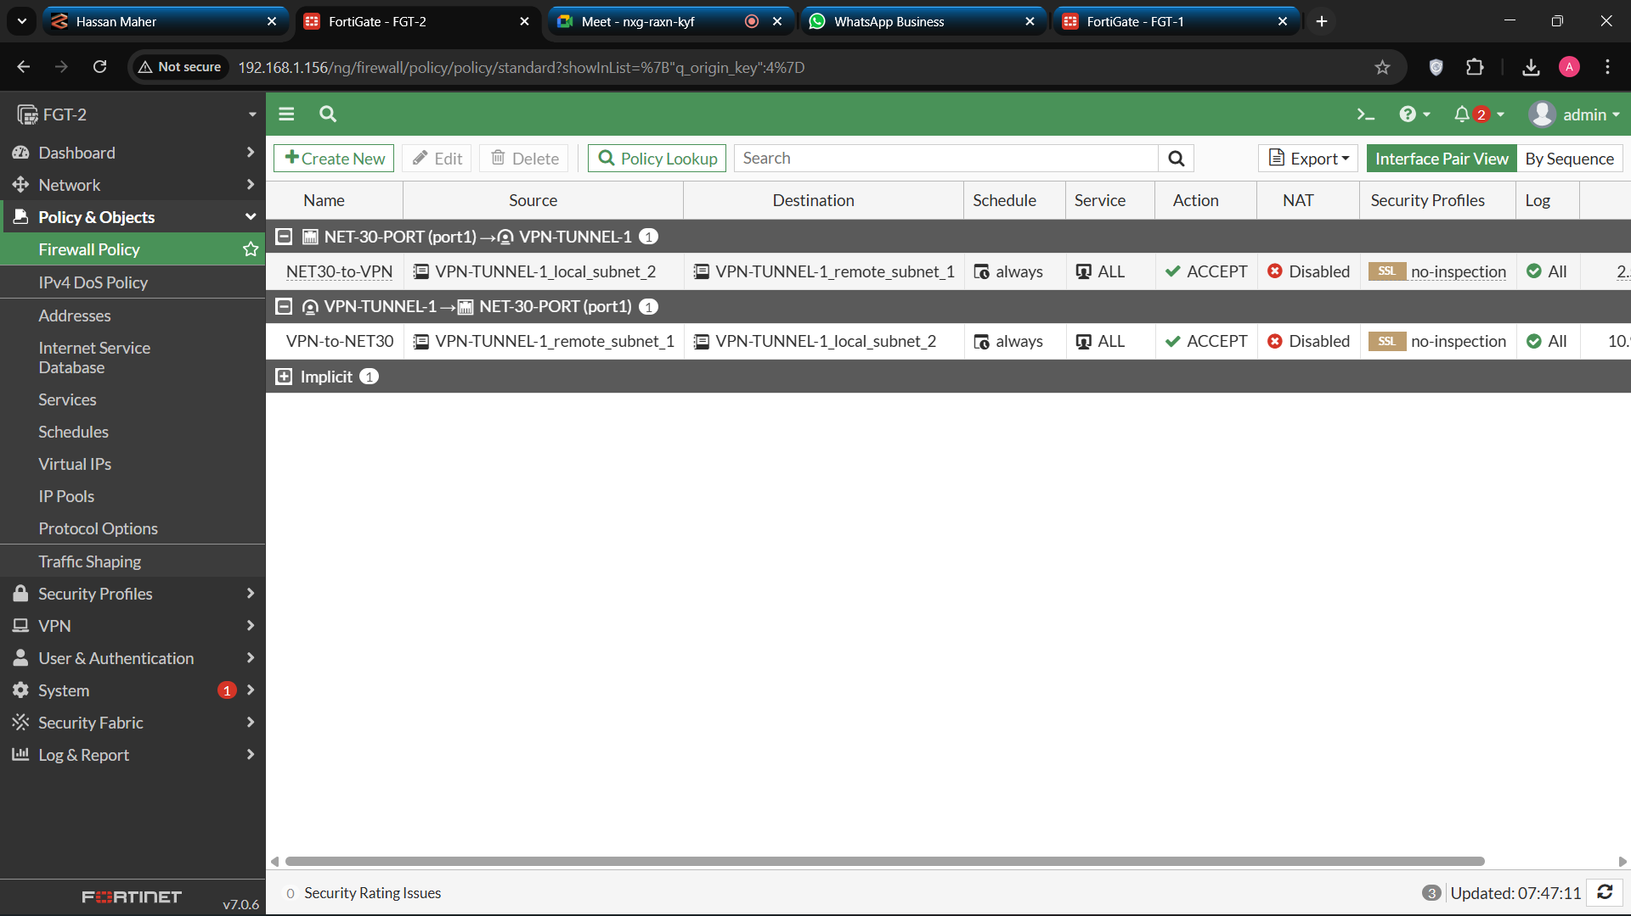

**e) Testing and Verification**

* 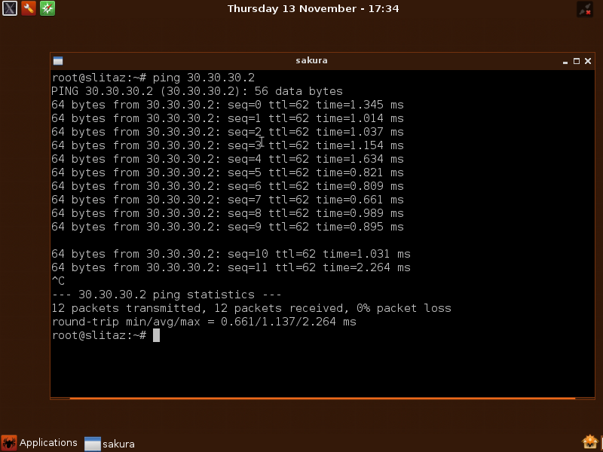**Ping Test:** **ping from PC-1 to PC-3**

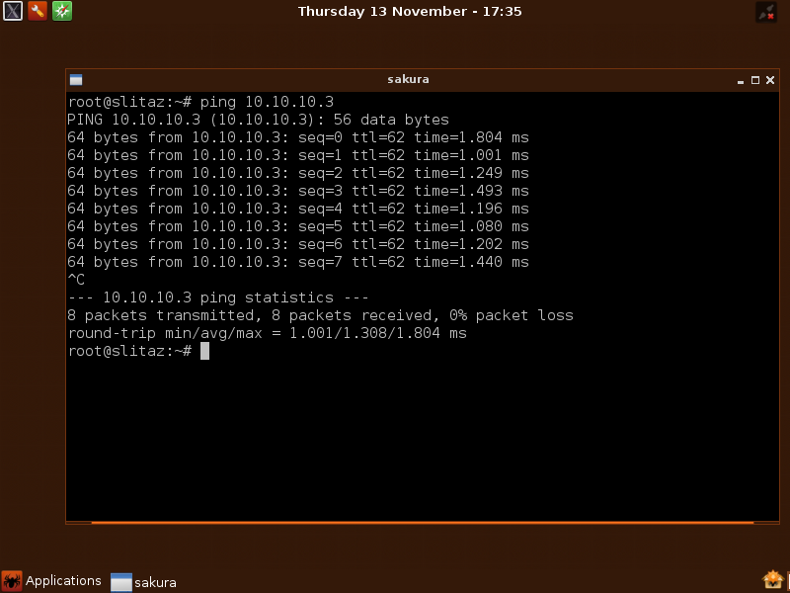**ping from PC-3 to PC-1**

**Capturing a traffic between PC-1 and PC-3 using Wireshark**

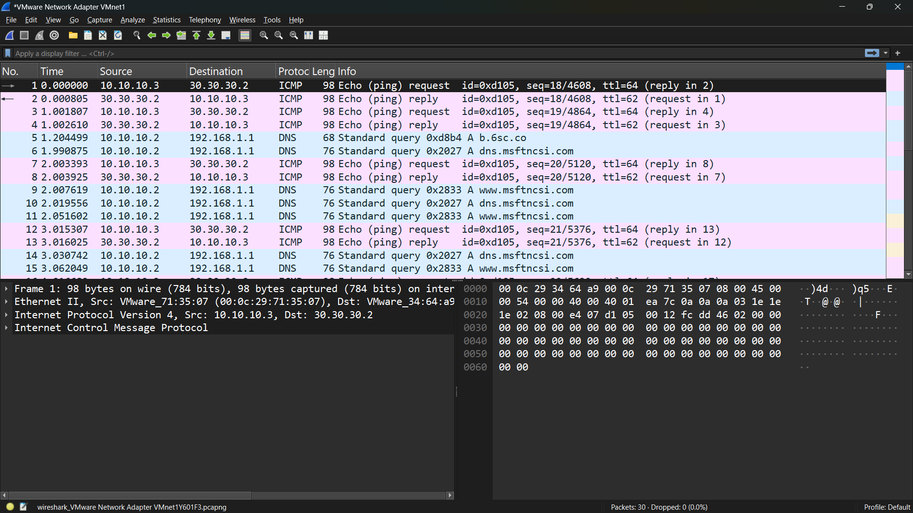

* 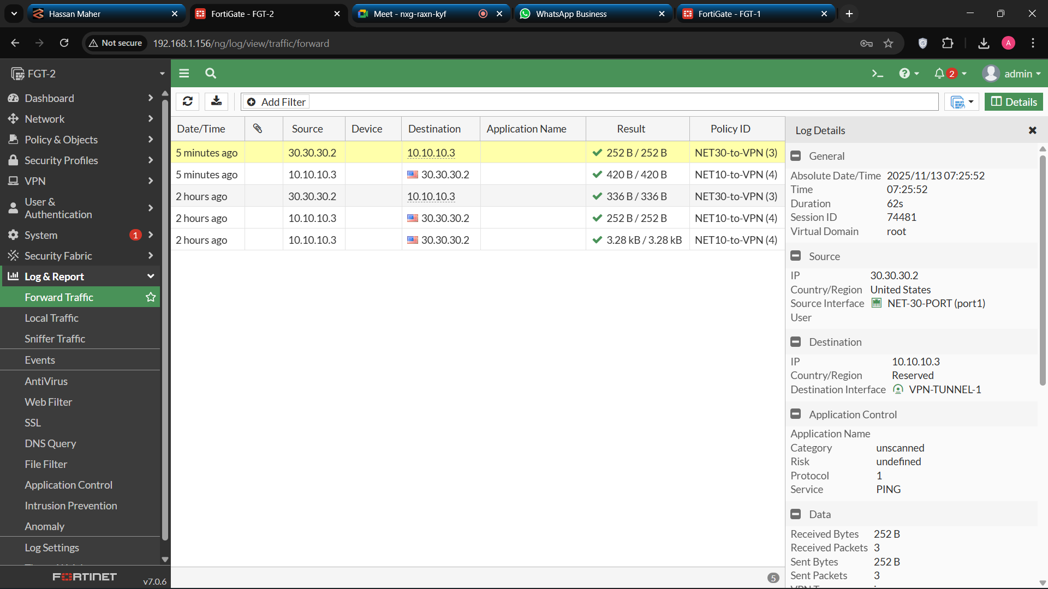**Logs and Events**
* 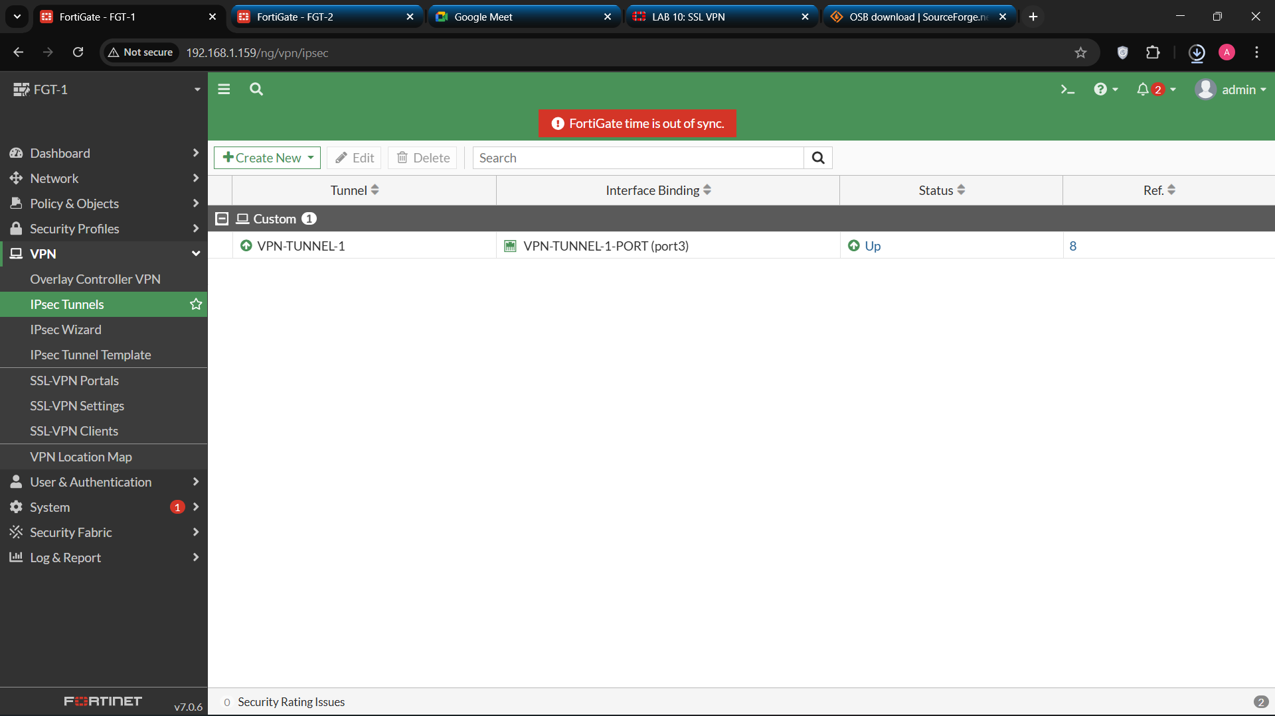**Tunnel Status:**

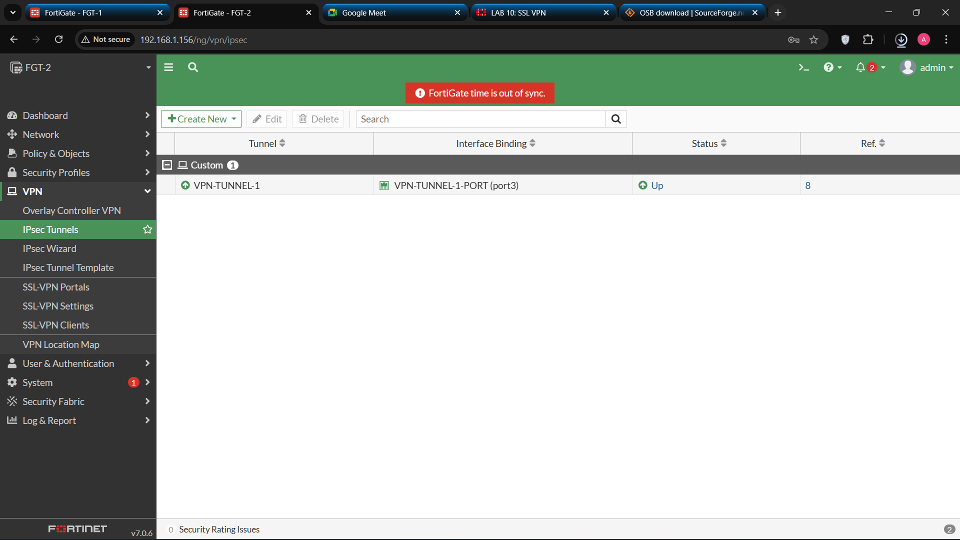

**f) Advantages of IPsec VPN**

* Strong encryption and authentication.
* Ideal for permanent site-to-site connections.
* Transparent to users and applications.
* Supports redundancy with multiple WAN links.

**Week 3: FortiGate VPN with SD-WAN Integration**

**a) Overview**

* **SD-WAN (Software-Defined Wide Area Network)** is an advanced networking technology that enhances WAN performance by intelligently directing traffic across multiple WAN connections (such as MPLS, broadband, or LTE).  
  Integrating SD-WAN with VPN allows FortiGate devices to **dynamically select the best path** for VPN traffic based on real-time performance metrics.

**b) Benefits of SD-WAN Integration**

* Improved VPN performance and stability.
* Intelligent traffic steering based on latency, jitter, and packet loss.
* Cost-efficient use of multiple WAN connections.
* Centralized management and visibility.

**c) SD-WAN Configuration on FortiGate**

* 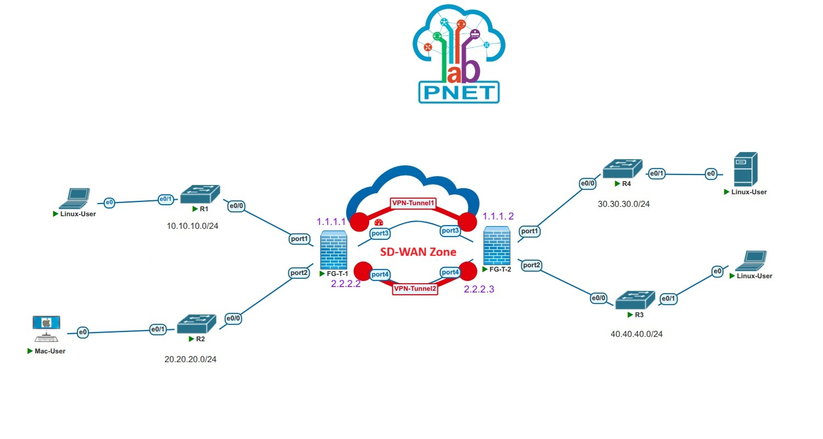**Objective:**  
  Integrate SD-WAN with VPN tunnels to ensure optimized routing for secure connections.

**VPN with SD-WAN Integration Topology**

* **Steps:**

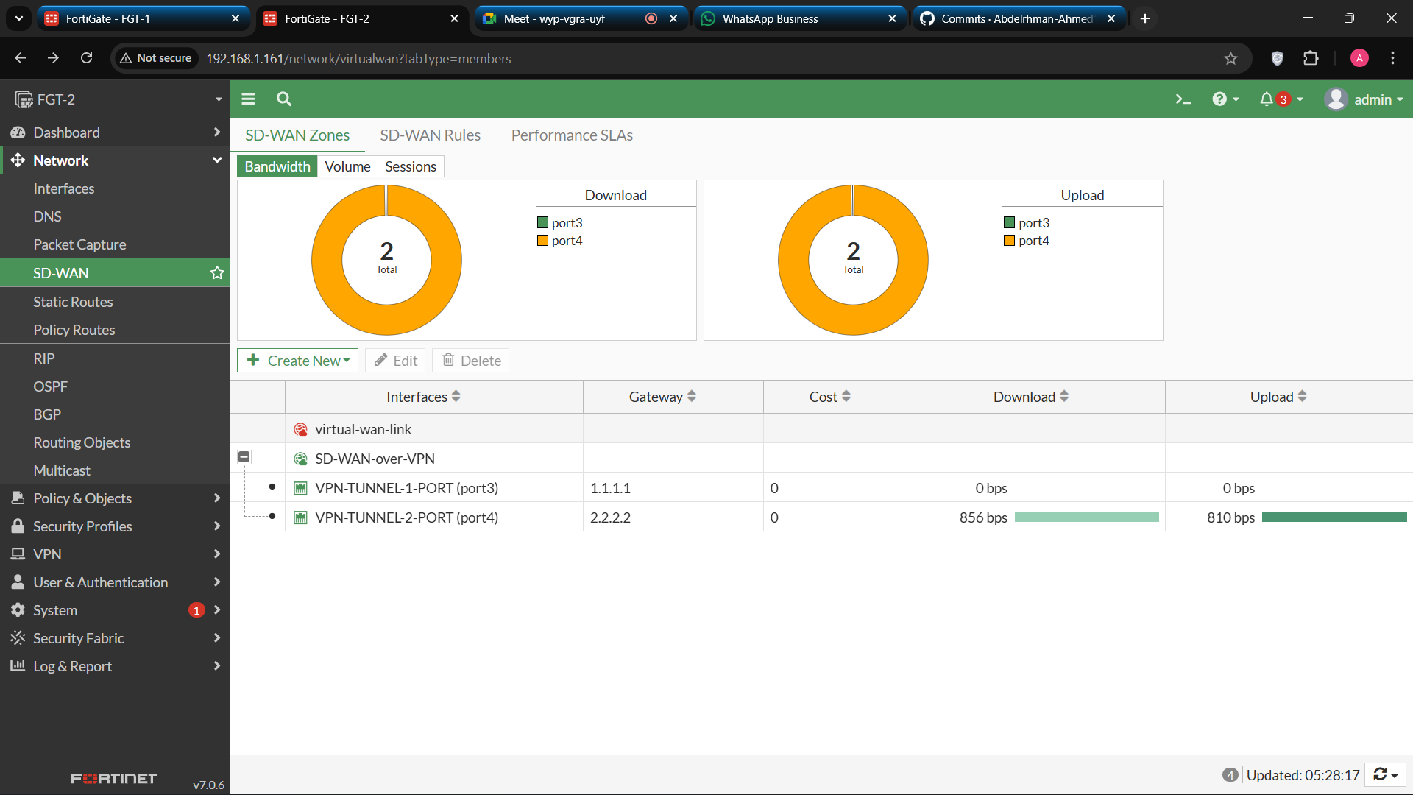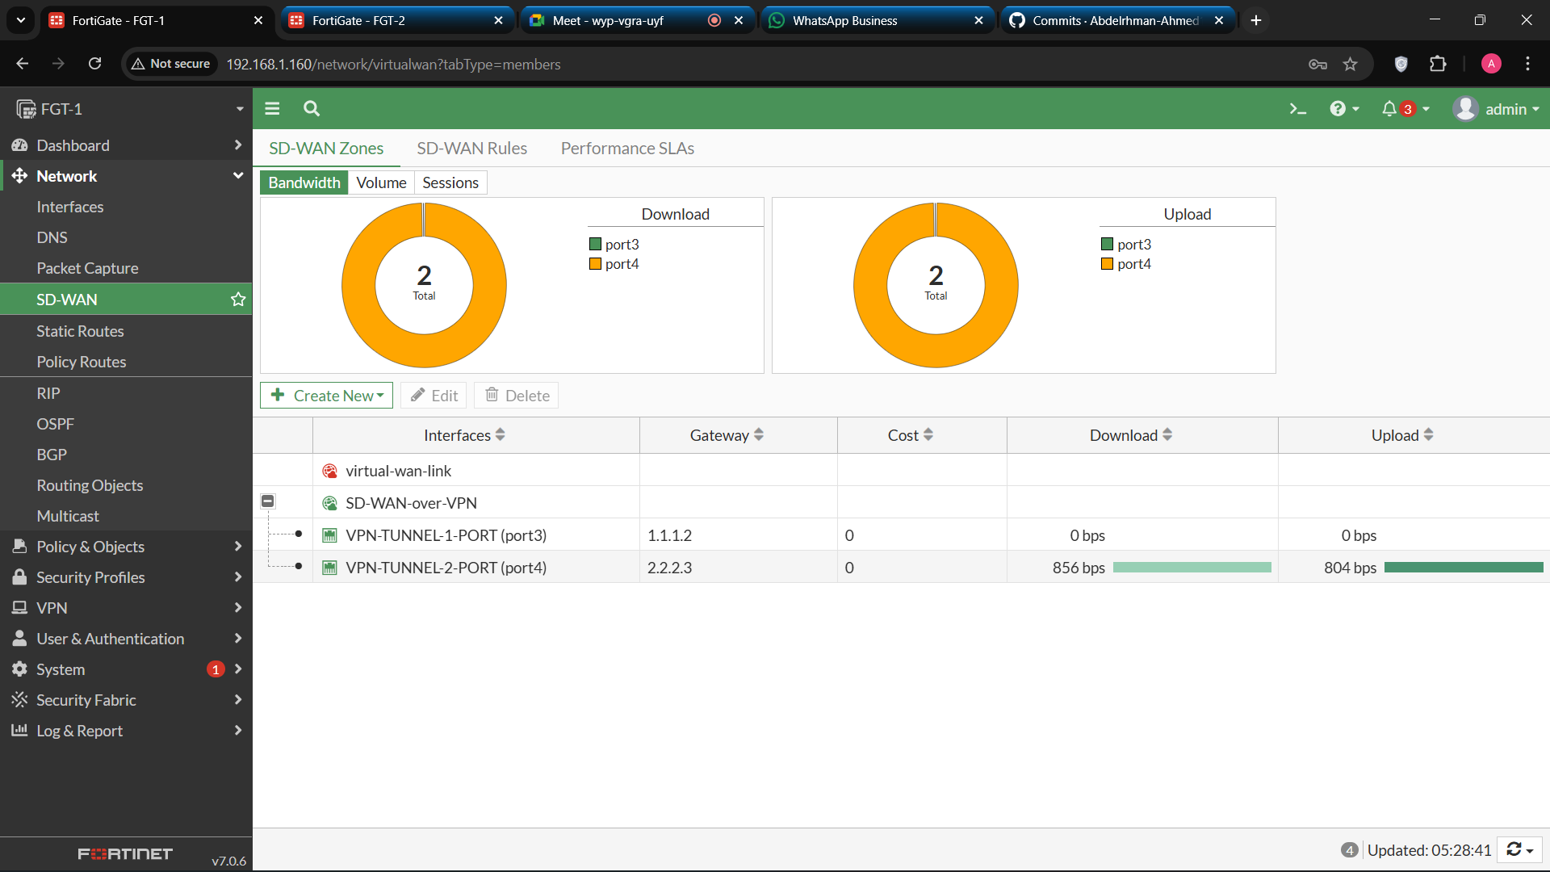**Step 1: create SD-wan zone, SD-wan members on FGT-1 and FGT2**

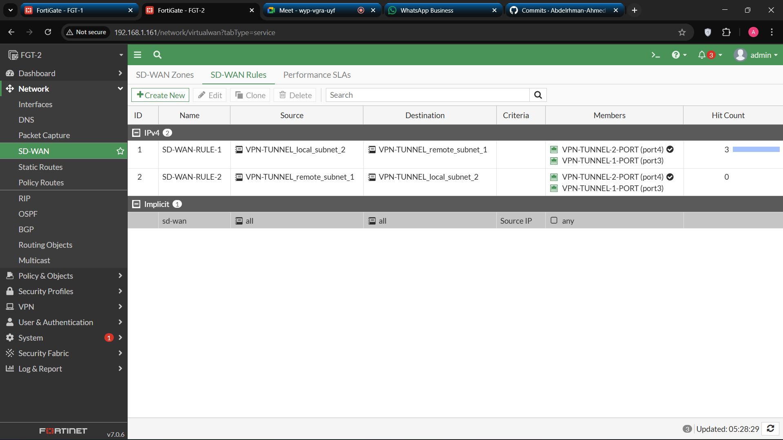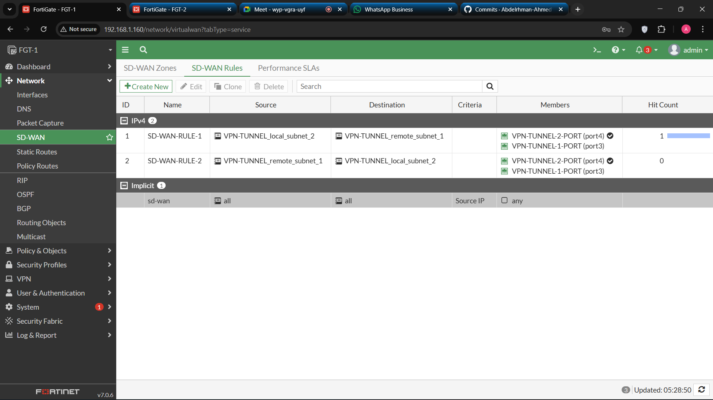**Step 2: Create SD-WAN Rules on FGT-1 and FGT-2**

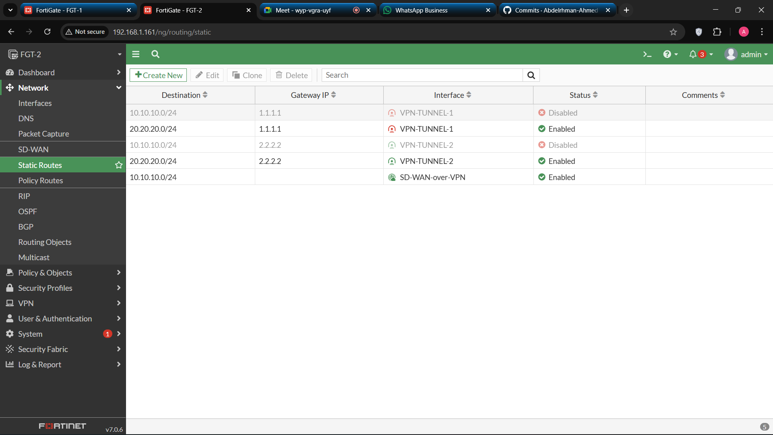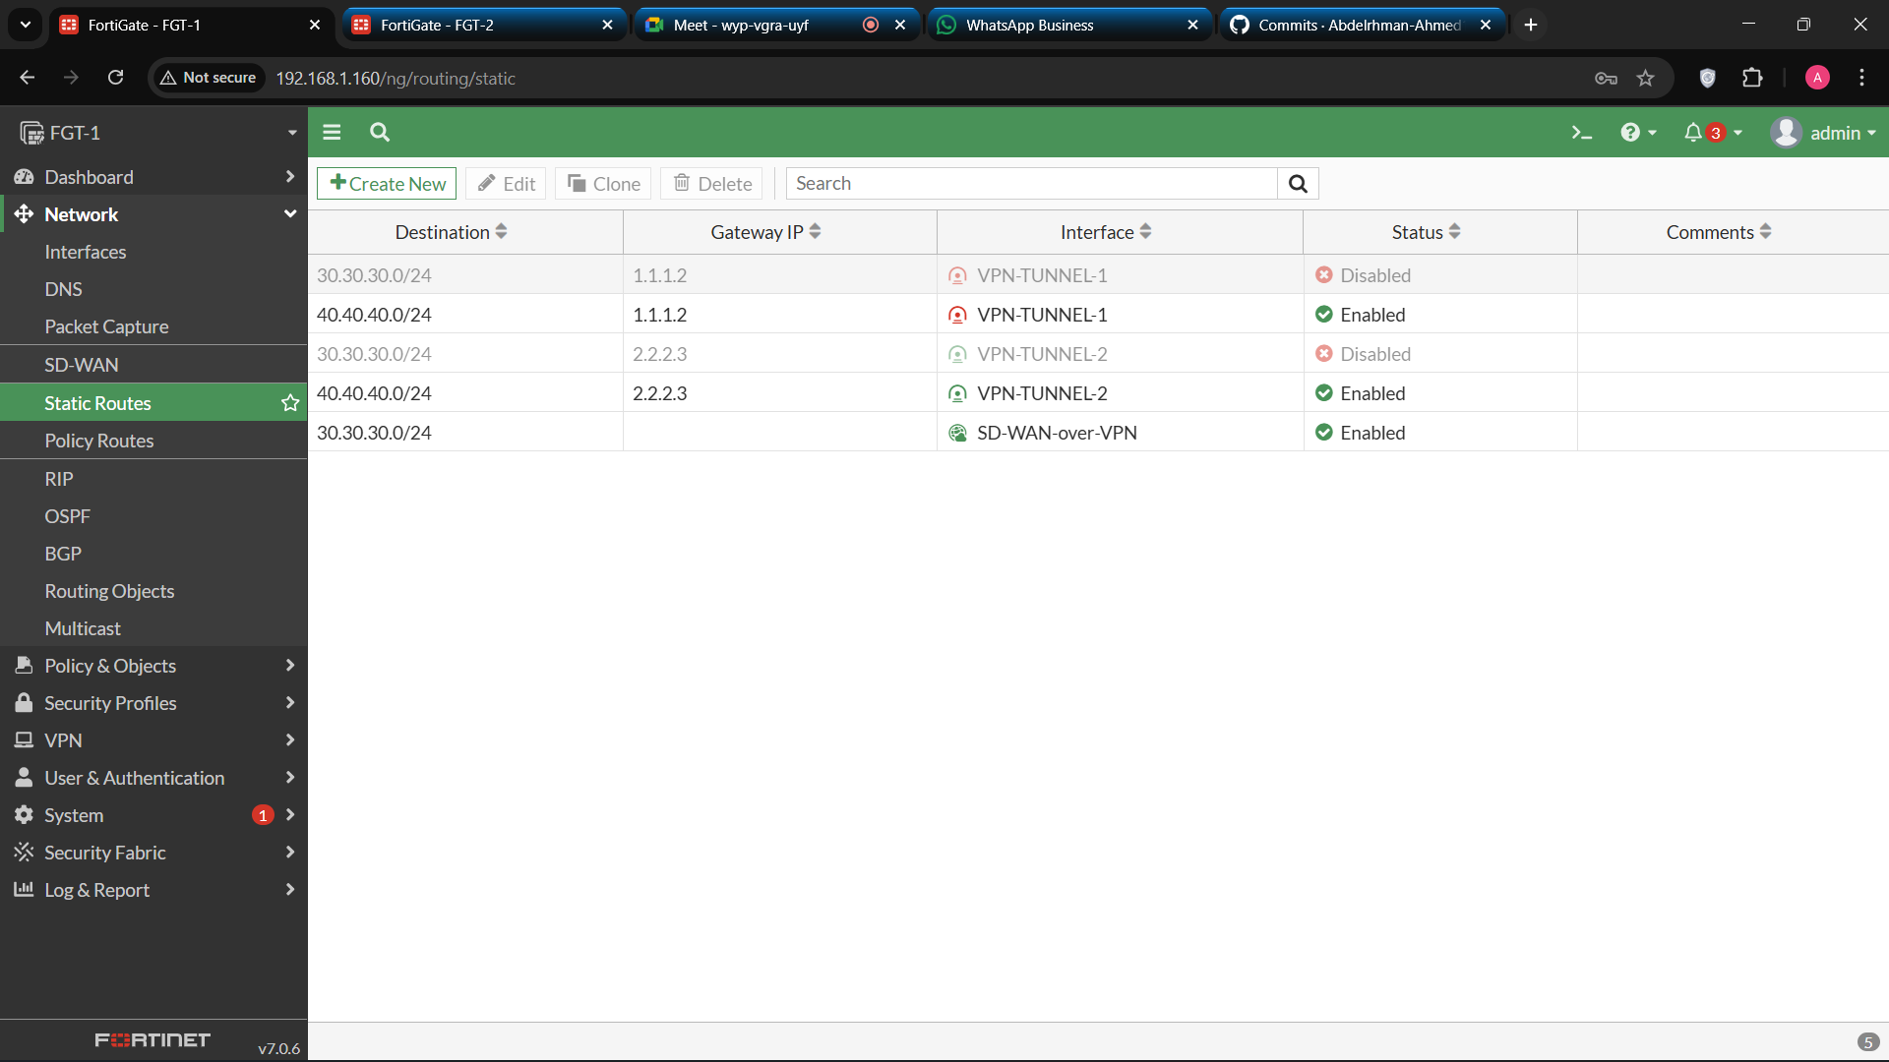**Step 3: Set Static Routes on FGT-1 and FGT-2**

**Step 4: Configure Policies**

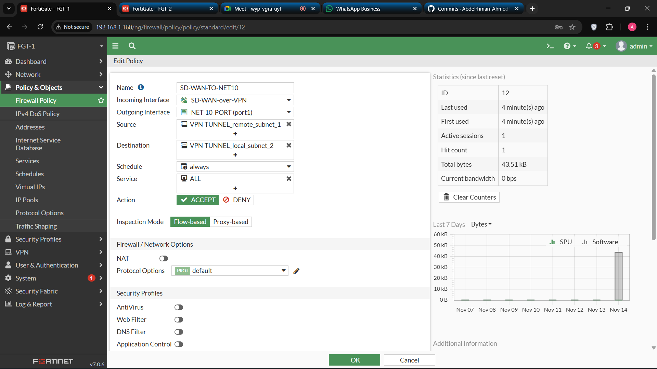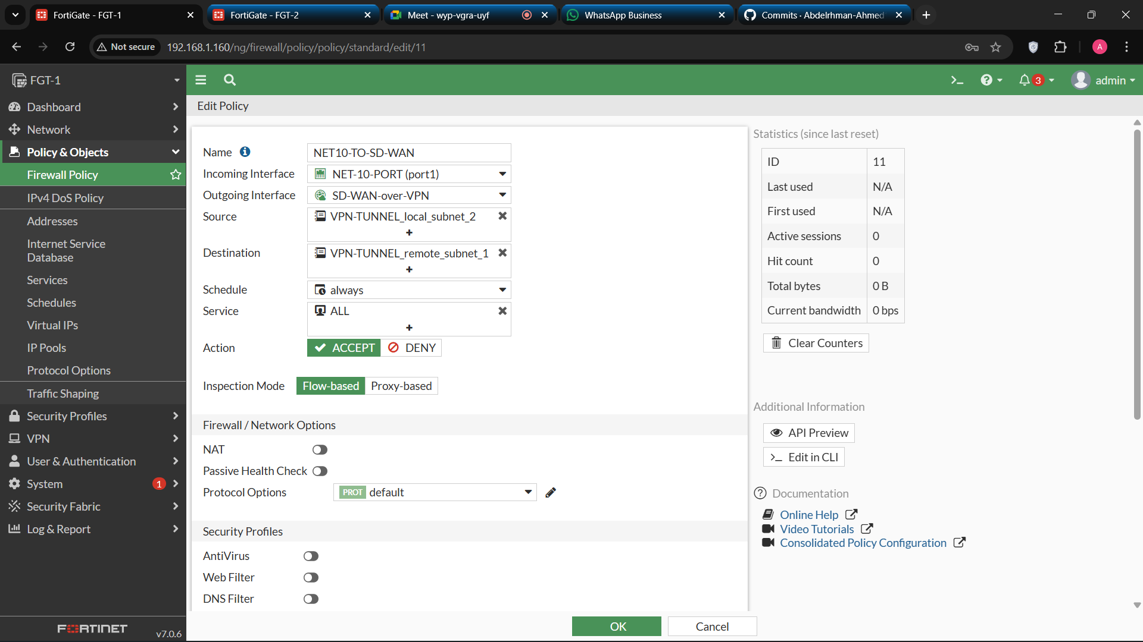

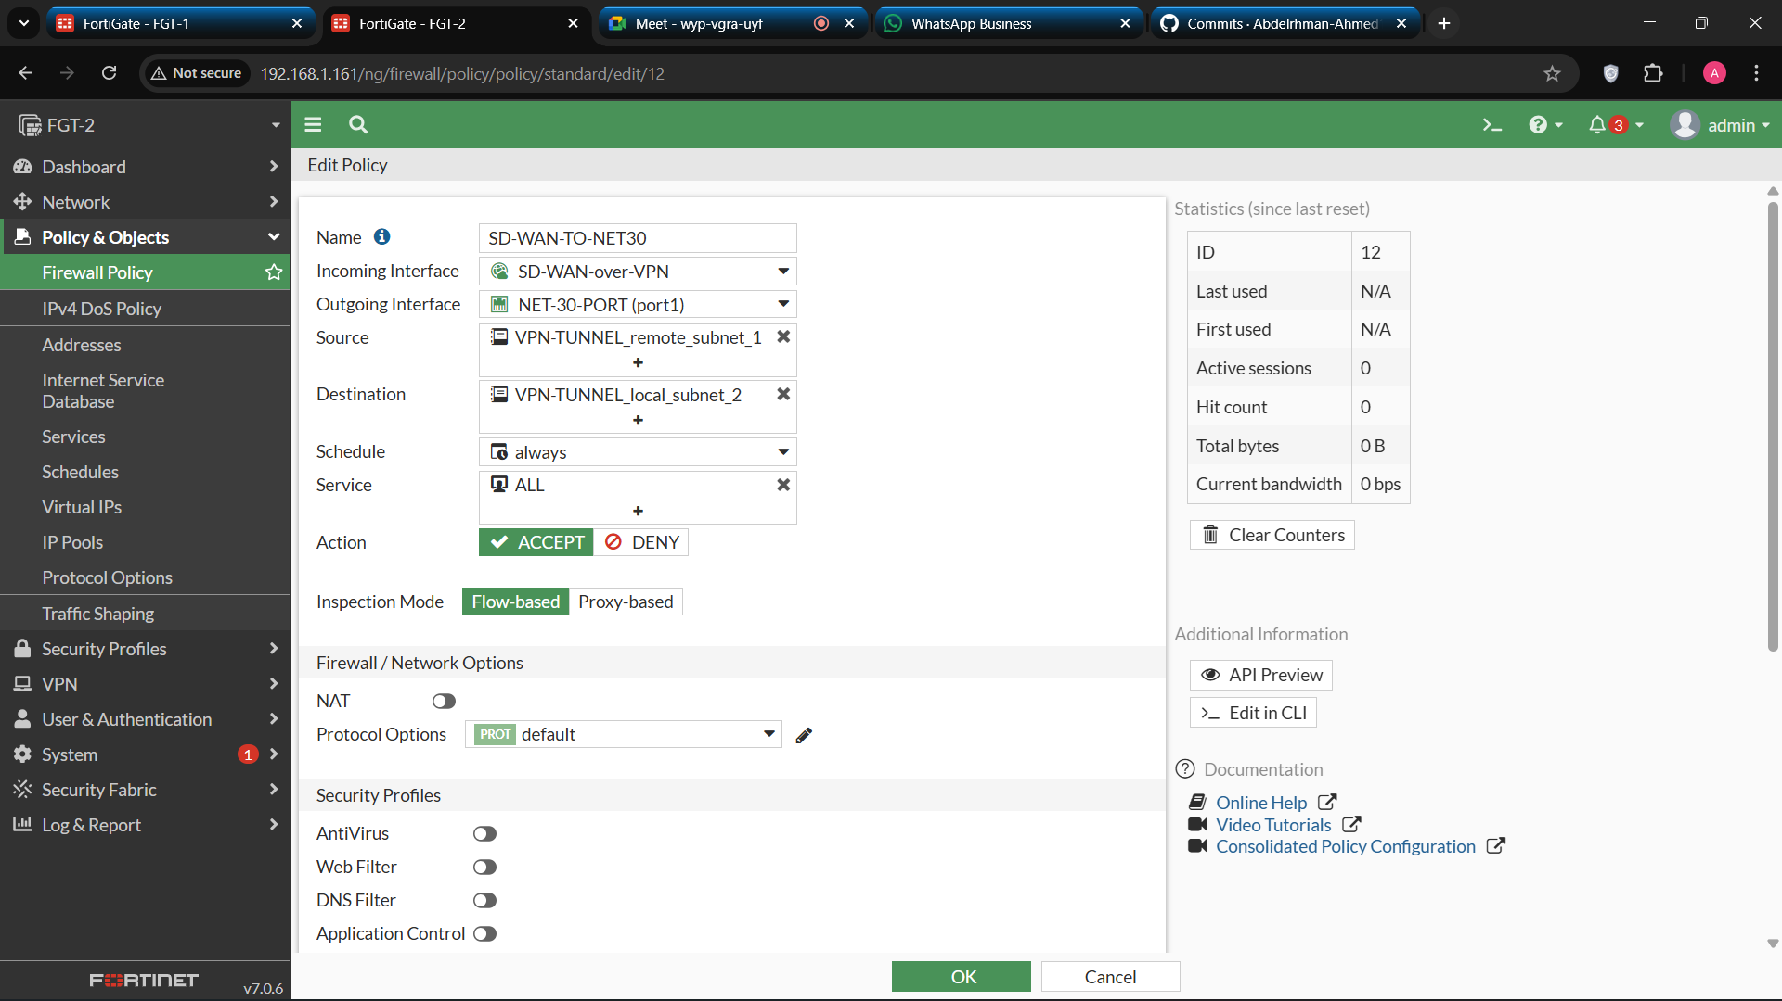

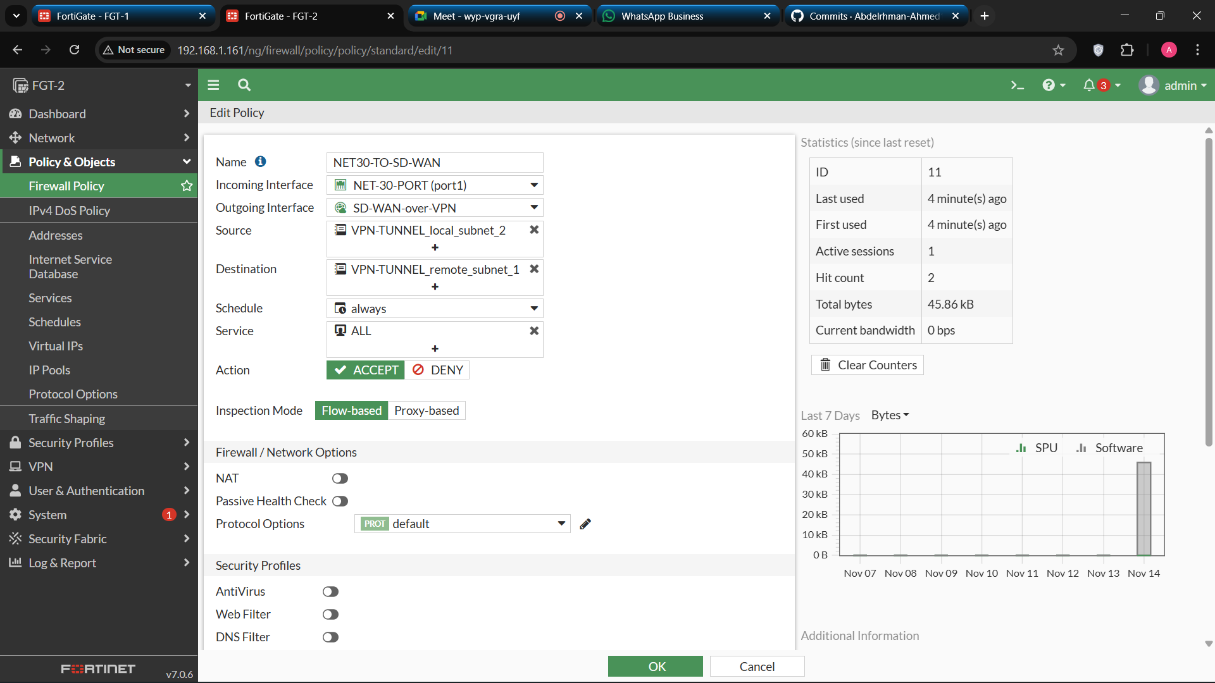

1. **Testing and Performance Evaluation**

**1. Tunnel 1 down and Tunnel 2 up**

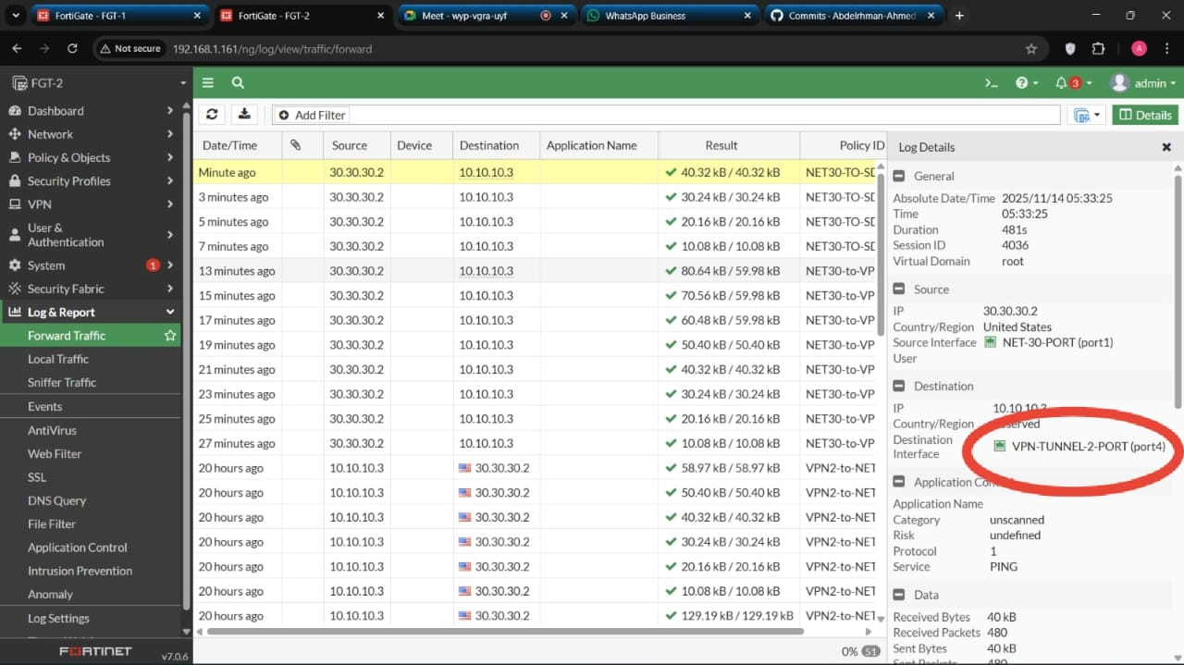

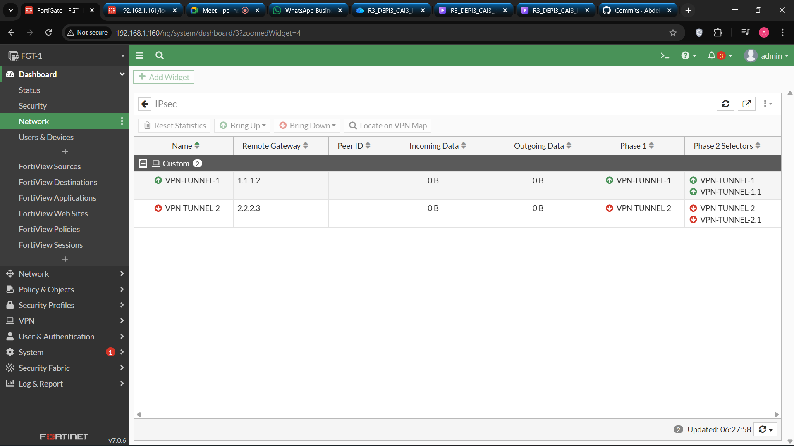**2. Tunnel 1 up and Tunnel 2 down**

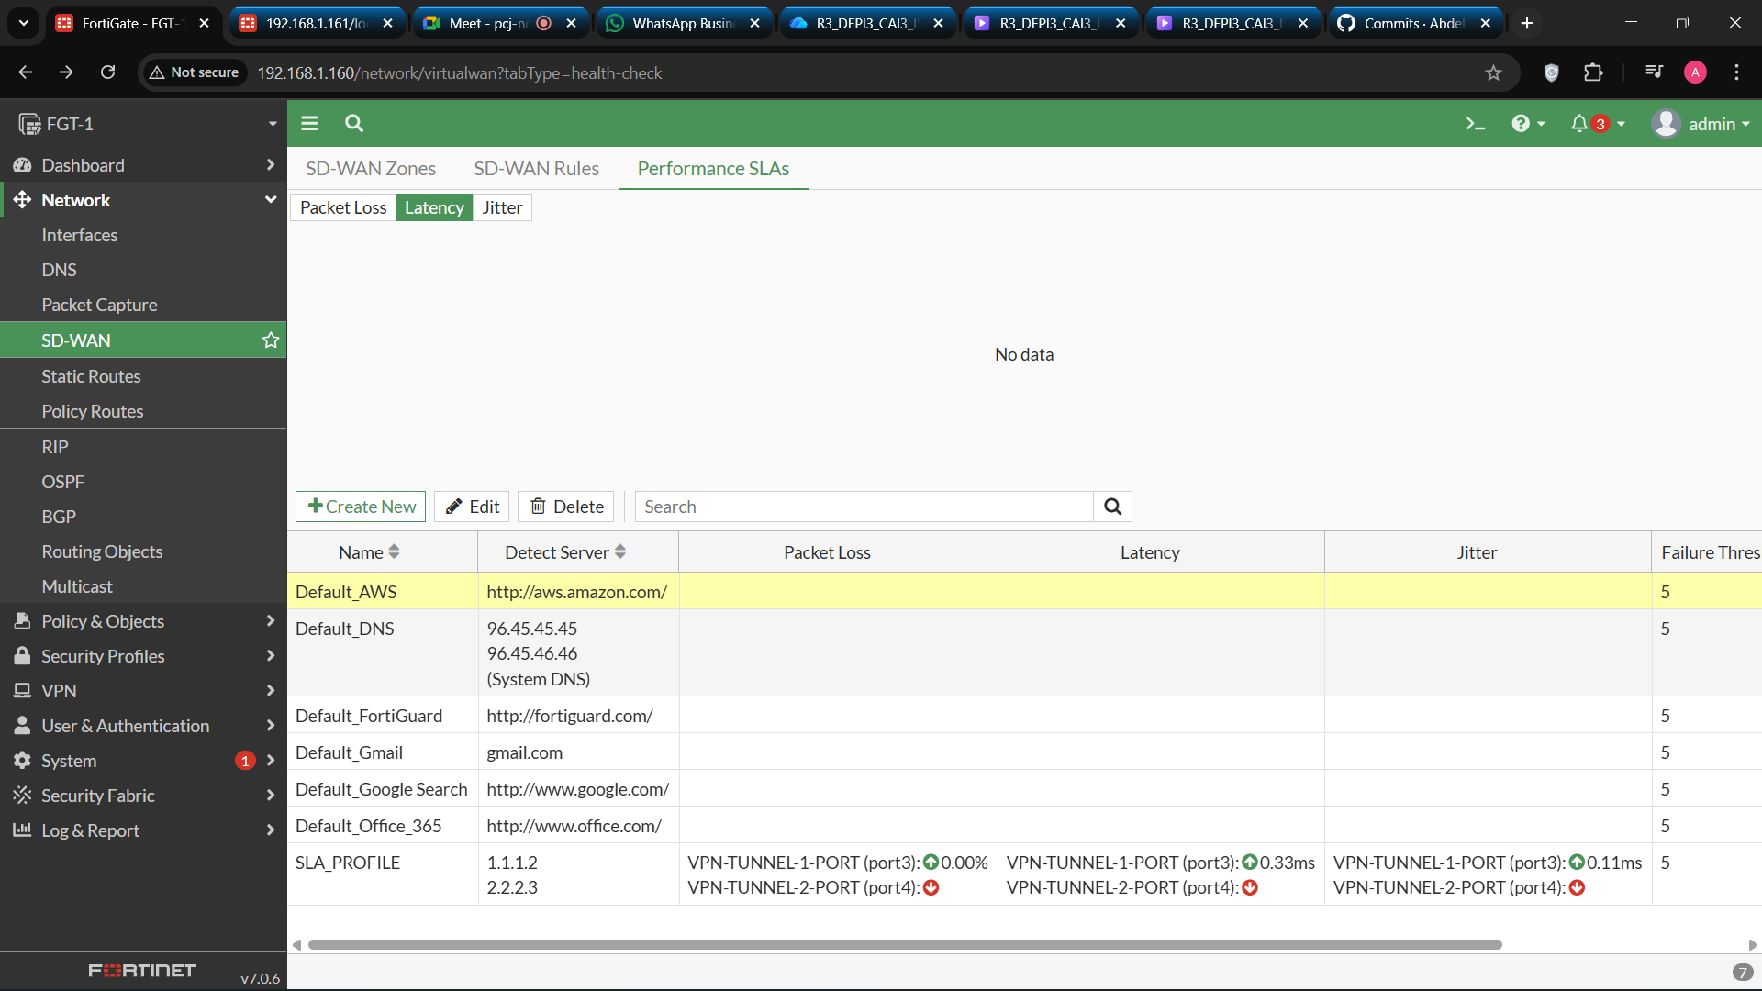

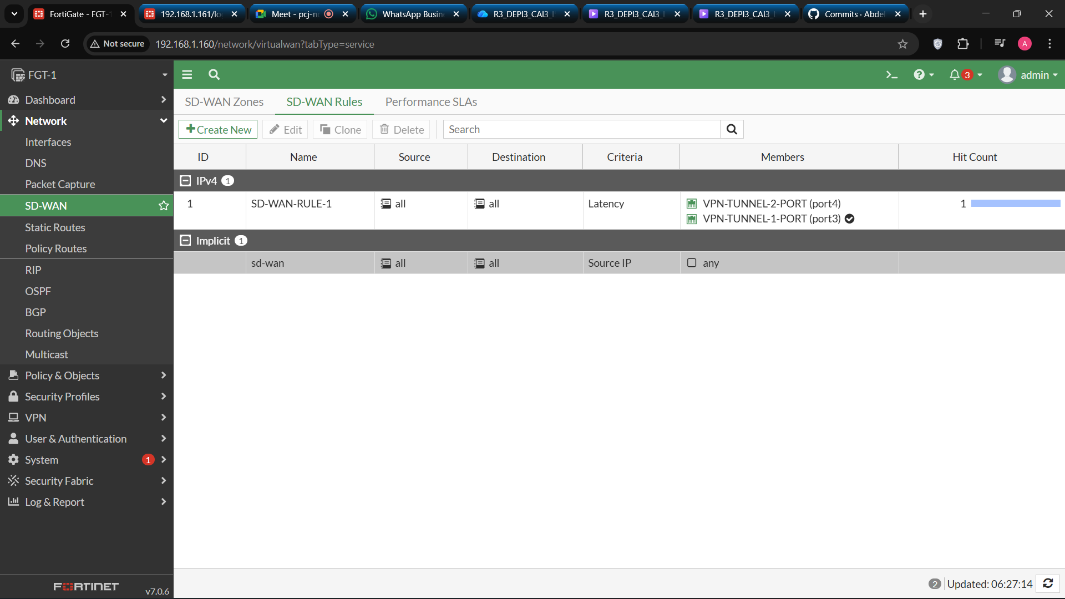

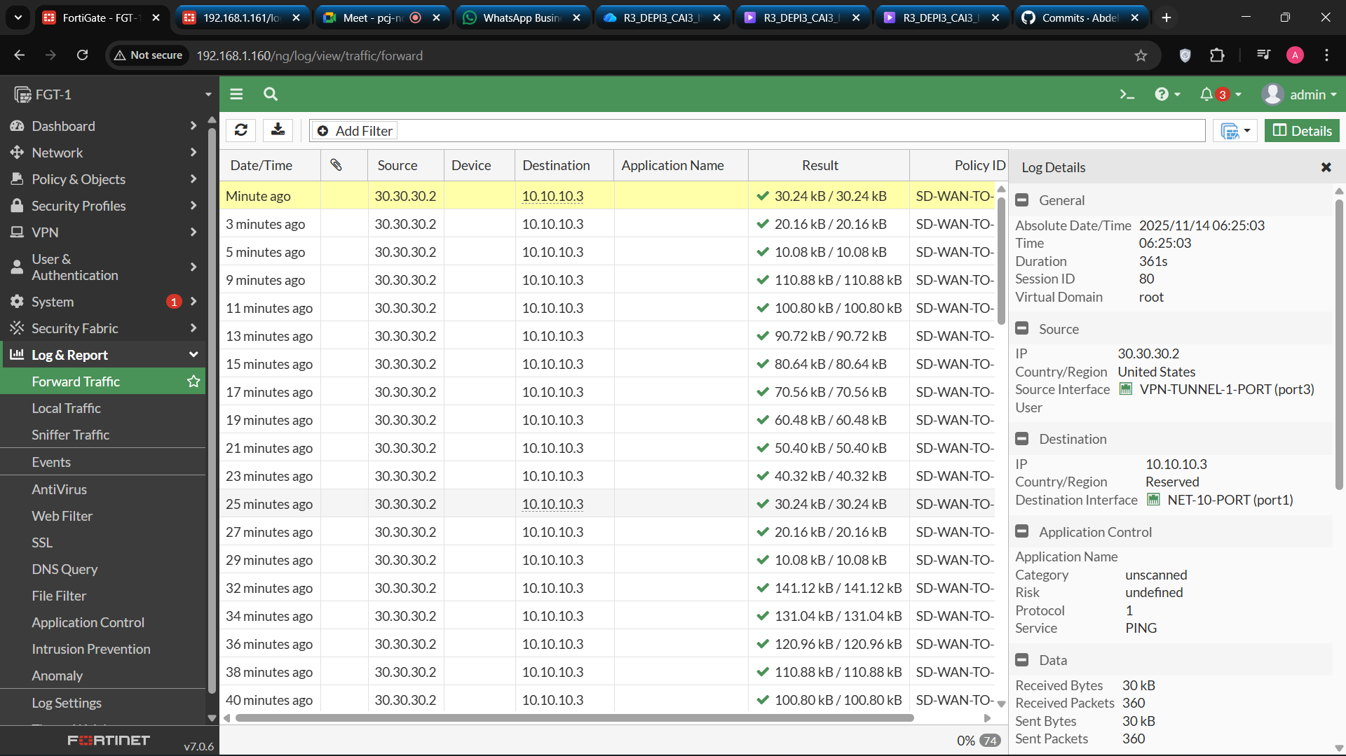

**Conclusion**

* This project successfully demonstrated the implementation of **VPN solutions using FortiGate firewalls**.  
  By configuring **SSL VPN**, **IPsec VPN**, and **SD-WAN**, the project achieved:
* **Secure remote and site-to-site connectivity**
* **Improved network performance and reliability**
* **Effective utilization of multiple WAN connections**
* Through rigorous testing and documentation, it was confirmed that FortiGate’s VPN and SD-WAN features provide an enterprise-grade, secure, and flexible solution for modern networking environments.

**References**

1. Fortinet Documentation – *FortiGate VPN Configuration Guide*
2. National Telecommunication Institute (NTI) – *Network Security Course Notes*
3. RFC 4301 – *Security Architecture for the Internet Protocol*
4. Fortinet – *SD-WAN Deployment Best Practices (2024)*